# Model list

* LP model
* Make vs. Buy Decisions
  + Has two cost:
    - Buying cost
    - Making cost
  + Let us make decision make or buy
* Blending Problem
* An Investment Problem
* Multi-Period Cash Flow Problem(?)
* The Fixed-Charge Problem

# W1

## What are Business Analytics

* solve business problems overlap with:
  + Operations Research
  + Management Science
  + Decision Science

## Modelling Approach

* model is built purposely to exhibit features and characteristics of some other objects
* uses models to make decisions
* Characteristics of model
  + Usually, simplified versions of things
  + A valid model accurately represents the relevant characteristics of the object or decision problem
* Models for Decision Making include:
  + Mathematical equations
    - * Mathematical Models
  + Structured set of rules or steps to follow
    - * Algorithms and Discrete Event processes
  + Simulation of real events
    - * Queuing models, waiting lines
  + Statistical techniques
    - * Data Analysis, Equation Fitting
* Why Model
  + reveal hidden inner relationships
  + Formal Analysis (assumptions/relationships)
  + Experimentation - can be used repeatedly
  + To large extent, independent of the data
  + Variety of models for the same problem
* Benefits of Modelling
  + Economy
    - Less costly to analyze decision problems
  + Timeliness
    - Deliver needed information more quickly
  + Feasibility
    - Used to do things that would be impossible in reality.
  + Insight & understanding
    - improves decision making.
* Benefits of Using Model
  + Less expensive and disruptive than experimenting with real world system
  + Models enable us to ask ‘what if’ questions and test the sensitivity of particular values
  + Models force a consistent, systematic approach to a problem
  + Models require managers to be specific about constraints and goals
  + Models can reduce the time taken to make decisions
* Disadvantages of Using Model
  + May be expensive to develop and test
  + May be misused and misunderstood because of their complexity
  + Models may ignore the value of non-quantifiable information
  + May oversimplify the variables of the real world

## Mathematical Model

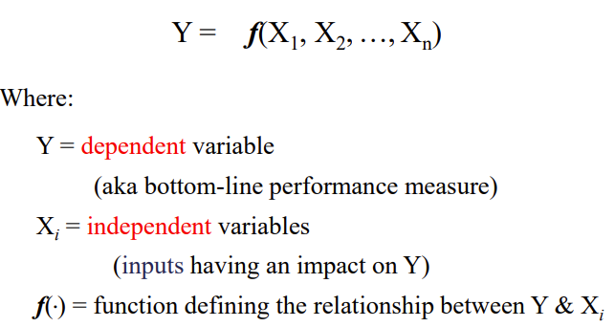

#### Categories of Mathematical Models

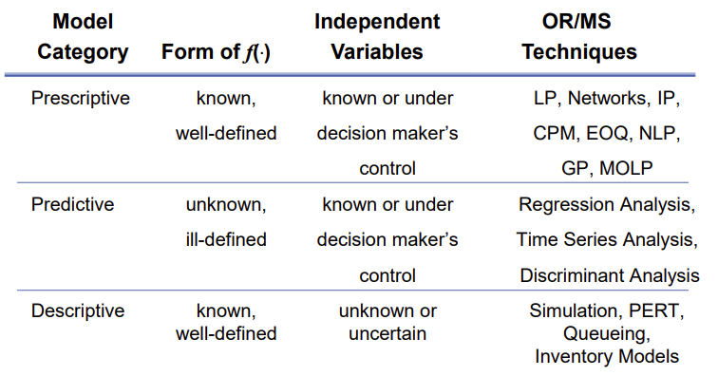

## Problem-Solving Framework for Leveraging Business Opportunities

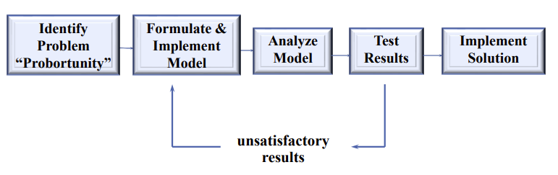

### Psychology of Decision Making

* Models can be used for structural aspects of decision problems.
* Other aspects cannot be structured easily, requiring intuition and judgment.
* Caution: Human judgment and intuition are not always rational!
* Errors in human judgment often arise because of anchoring and framing effects associated with decision problems.
  + Anchoring Effects
    - when trivial factors influence initial thinking
    - 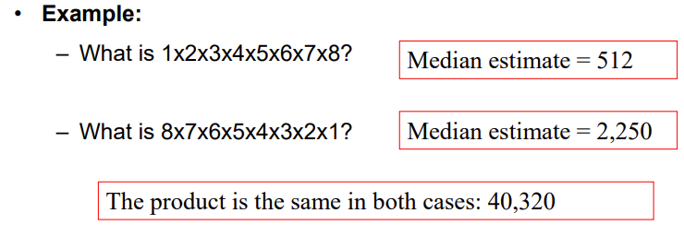
  + Framing Effects
    - how decision-makers view a problem from a win-loss perspective.
    - 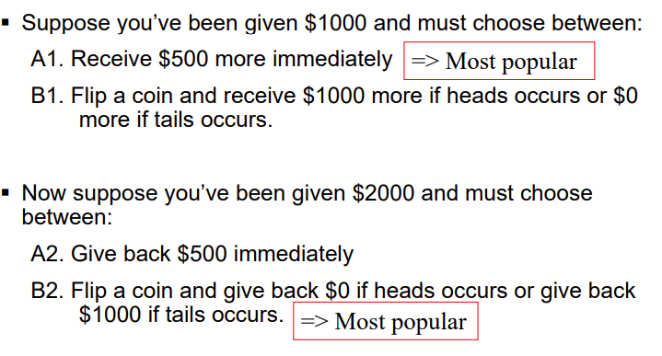
    - 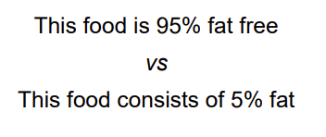
* Good decisions do not always lead to good outcomes
* good decision is one – What we can do – What we know – What we want

## LP problems

#### Characteristics

* Decisions
  + One or more decisions that must be made
* Constraints
  + Due to limited resources
* Objectives
  + Goal that decision maker considers when making decision
  + To maximise profit or minimise cost

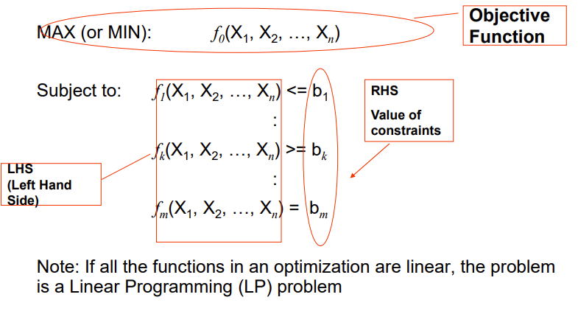

#### Formulating LP Models:

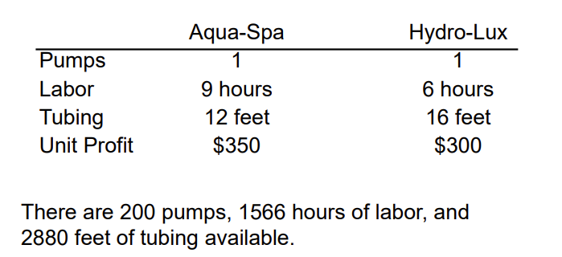

* Understand the problem.
* Identify the decision variables.
  + X1=number of Aqua-Spas to produce
  + X2=number of Hydro-Luxes to produce
* State the objective function as a linear combination of the decision variables.
  + MAX: 350X1 + 300X2

#### Special Conditions in LP Models

* Alternate Optimal Solutions
  + 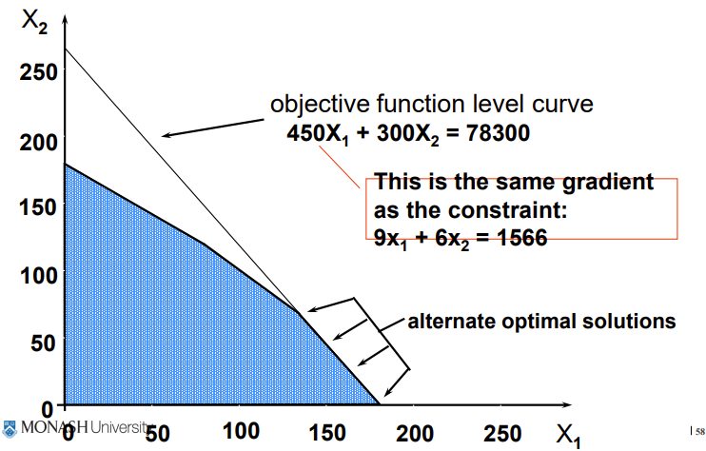
* Redundant Constraints
  + 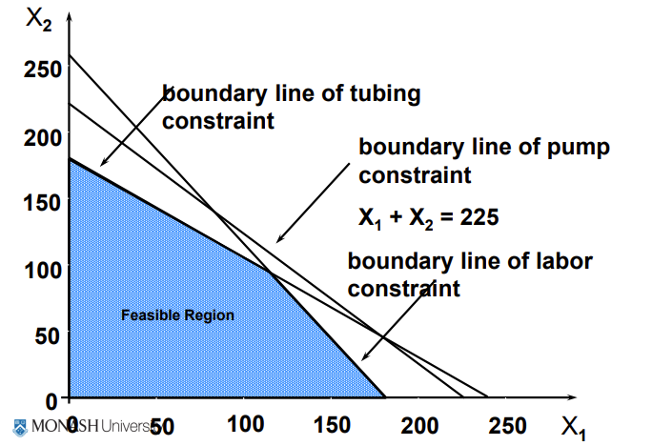
* Unbounded Solutions
  + 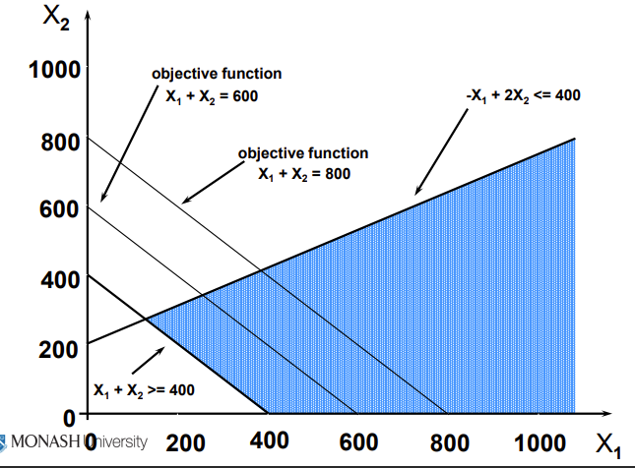
* Infeasibility
  + 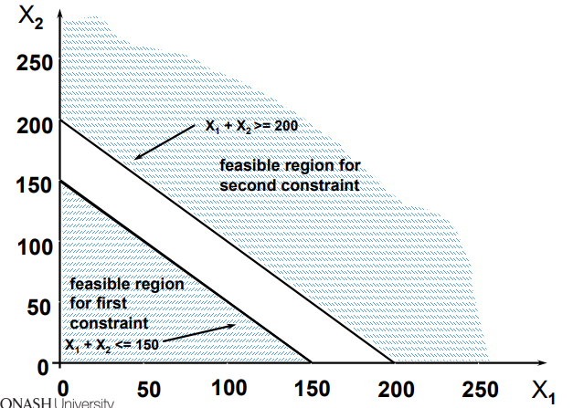

# W2

## Main challenges are:

* formulate LP problem.
* Communicate formulation to computer.
* Use a recognised variable layout.

## Steps

1. Organize the data for the model.
2. Reserve separate cells in the spreadsheet for each decision variable in the model.
3. Create a formula in a cell that corresponds to the objective function.
4. For each constraint, create a formula in a separate cell in the spreadsheet that corresponds to the left-hand side (LHS) of the constraint.

## Goals For Spreadsheet Design

* Communication - communicating information to managers.
* Reliability - The output a spreadsheet is correct and consistent.
* Auditability - A manager should be able to retrace the steps followed to generate the different outputs from the model in order to understand and verify results.
* Modifiability - spreadsheet should be easy to change or enhance in order to meet dynamic user requirements.

## Guidelines

* Organize the data, then build the model around the data
* Do not embed numeric constants in formulas.
* Things which are logically related should be physically related.
* Use formulae that can be copied.
* Column/rows totals should be close to the columns/rows being totalled.
* Use colour, shading, borders and protection to distinguish changeable parameters
* Use text boxes and cell notes to document various elements of the model.

## Make vs. Buy Decisions problem:

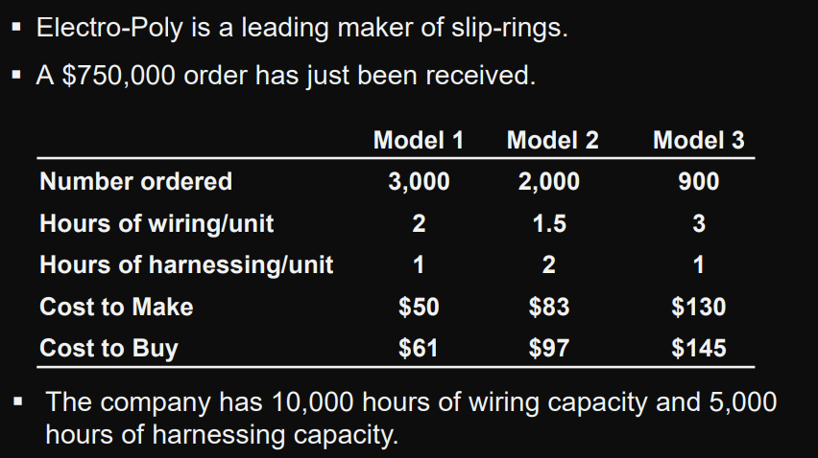

### Defining the Decision Variables

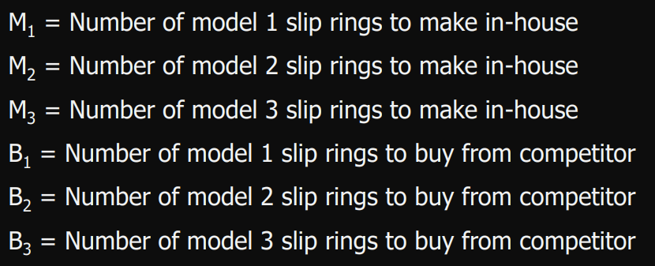

### Defining the Objective Function

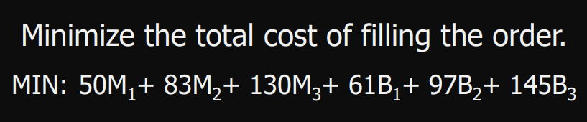

### Defining the Constraints

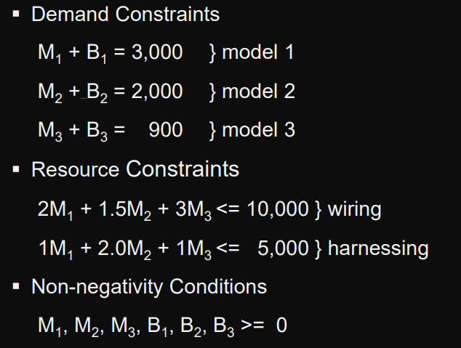

## An Investment Problem:

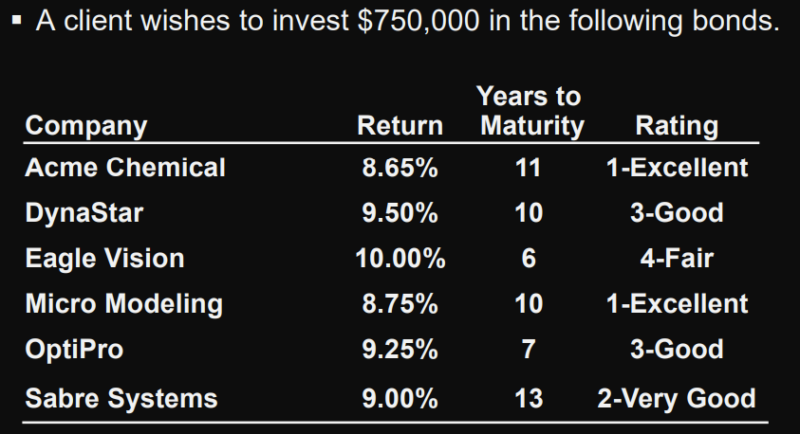

* No more than 25% can be invested in any single company.
* At least 50% should be invested in long-term bonds
* No more than 35% can be invested in DynaStar, Eagle Vision, and OptiPro

## Defining the Decision Variables

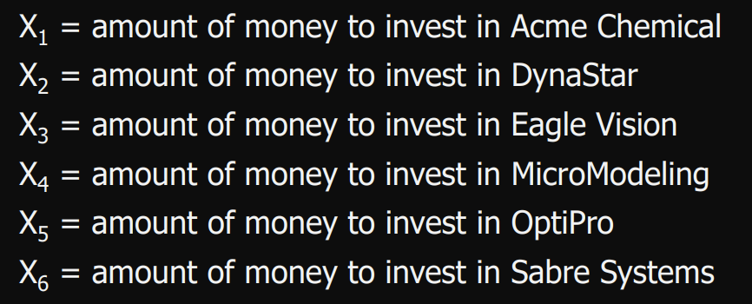

## Defining the Objective Function

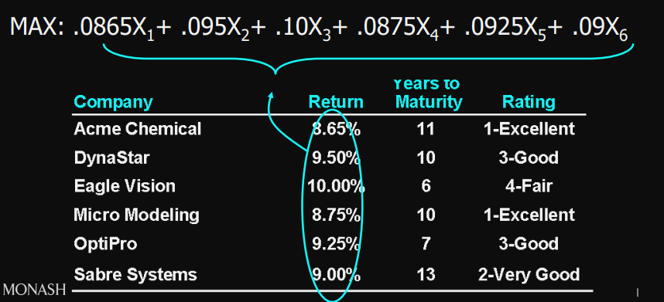

## Defining the Constraints

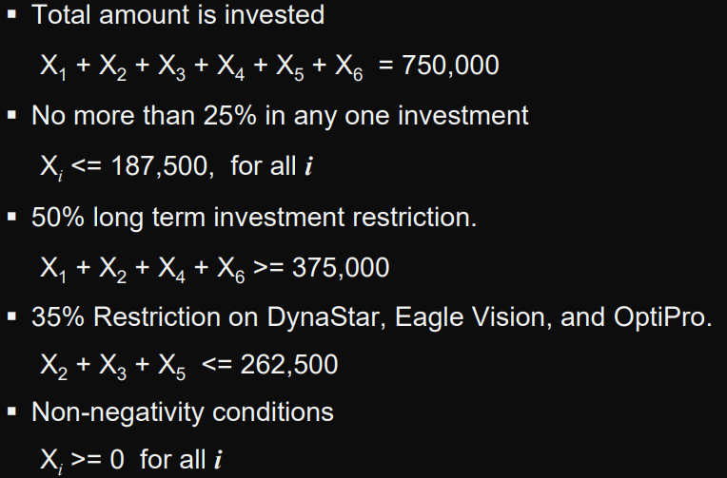

## A Blending Problem:

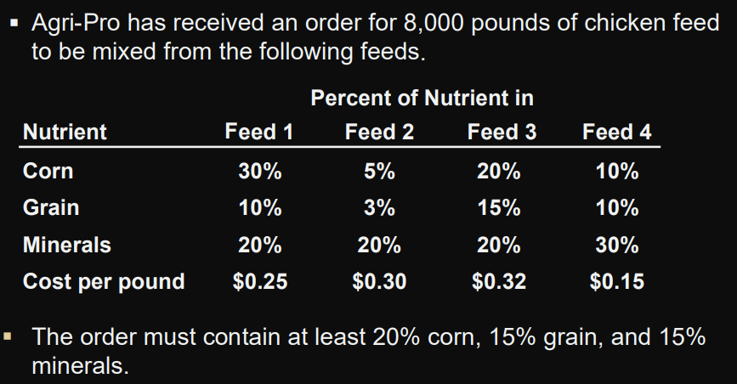

### Defining the Decision Variables

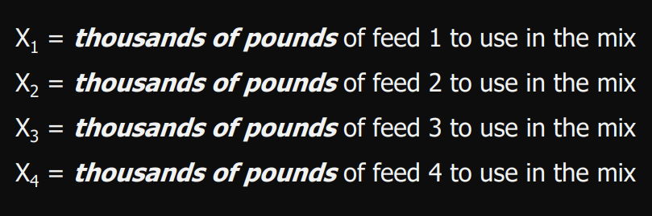

### Defining the Objective Function

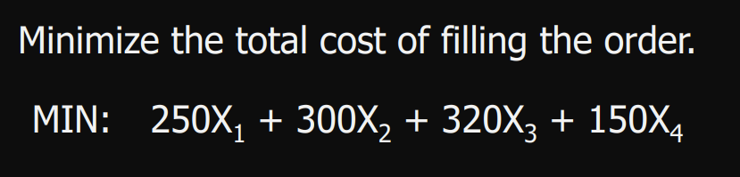

### Defining the Constraints

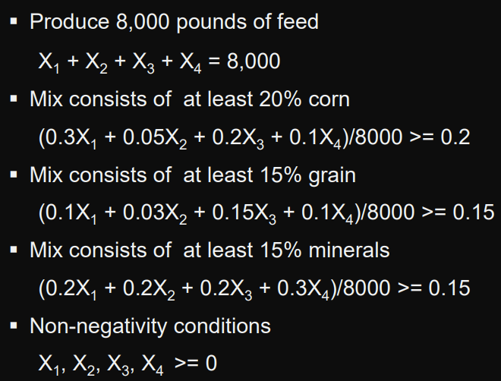

## A Multi-Period Cash Flow Problem:

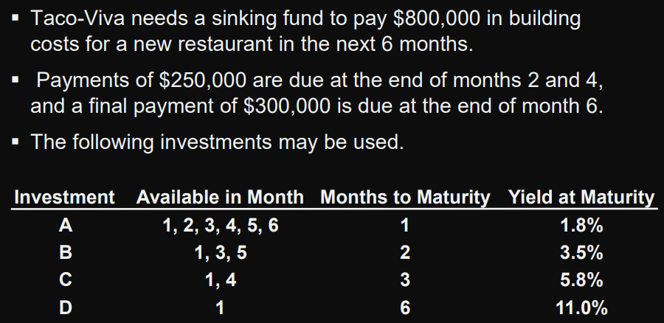

### Summary of Possible Cash Flows

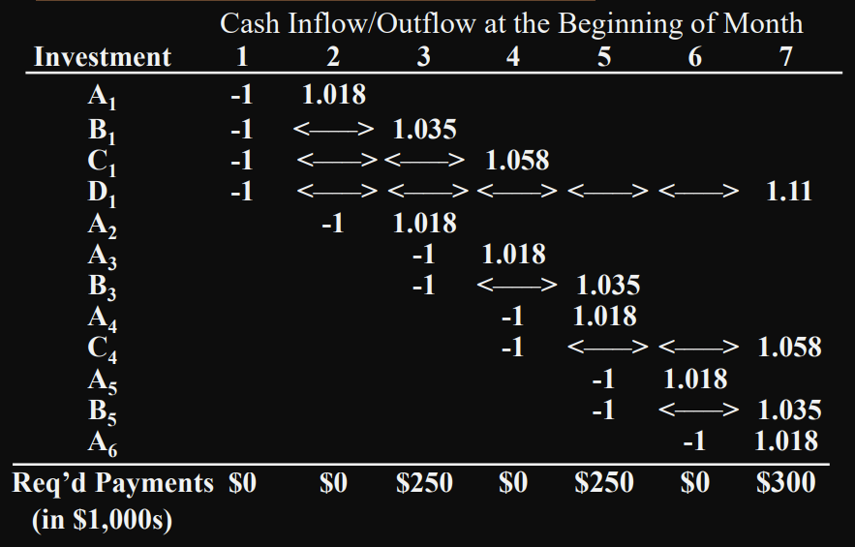

### Defining the Decision Variables

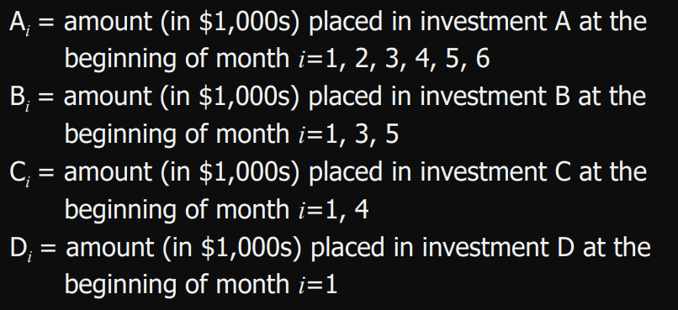

### Defining the Objective Function

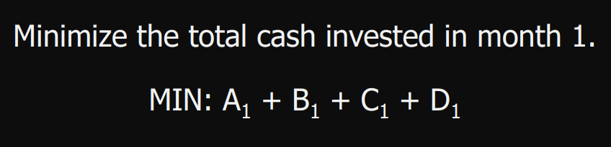

### Defining the Constraints

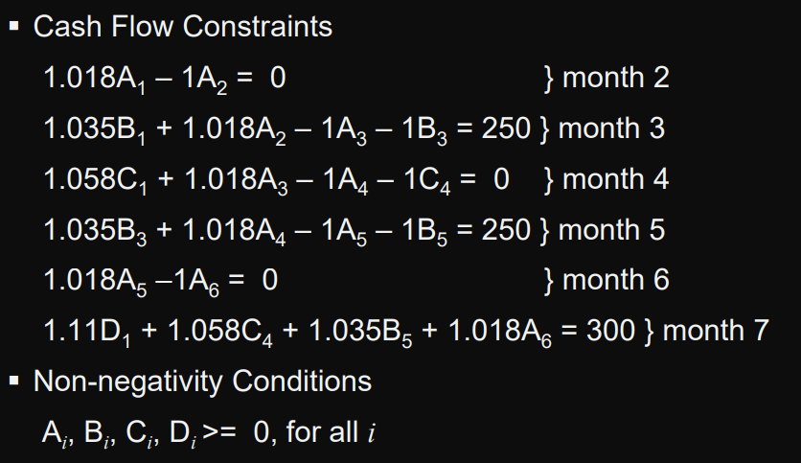

# W3

EXAMPLE:

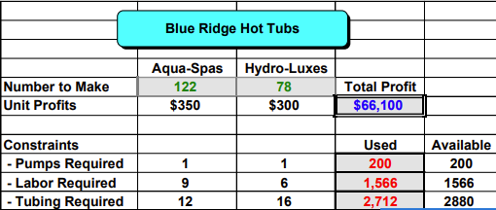

## Sensitivity Analysis

In lecture 1, we assume that values of all model coefficients are known with certainty but such certainty rarely exists.

Approaches

* Solver also produces sensitivity reports
* Change the data and re-solve the model

Sensitivity Report shows

* 目标函数系数(objective function coefficients)可以在不改变最优解的情况下改变的量
* 约束资源(constrained resources)变化对最优值的影响
* 决策变量(decision variables)变化对最优目标函数值的影响
* 约束系数(constraint coefficients)变化会对最优解产生影响

## General Form of a Linear Programming (LP) Problem

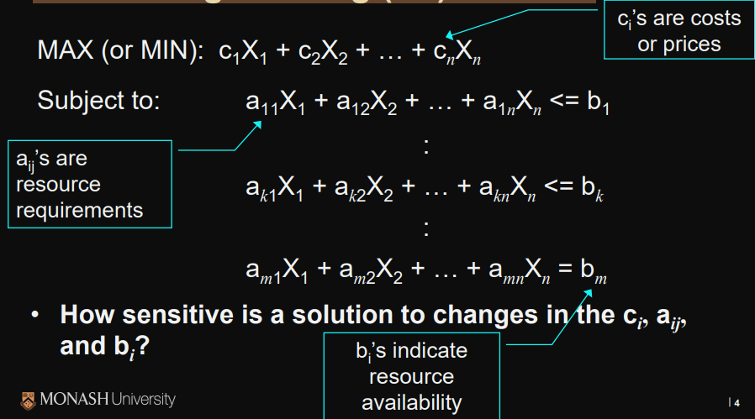

## Answer Report

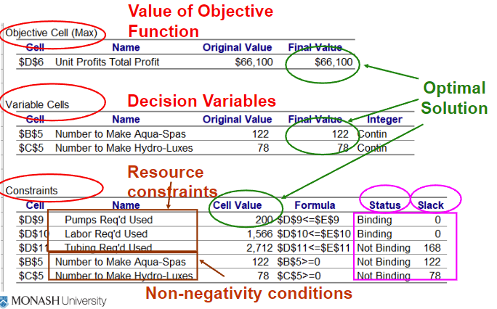

Section 1: Final value of optimal solution (obj.function).

Section 2: Final values of decision variables.

Section 3: How much of each resource is used.

**Status: Not binding means not full used**

**Slack: The quantity that not used**

## Sensitivity Report

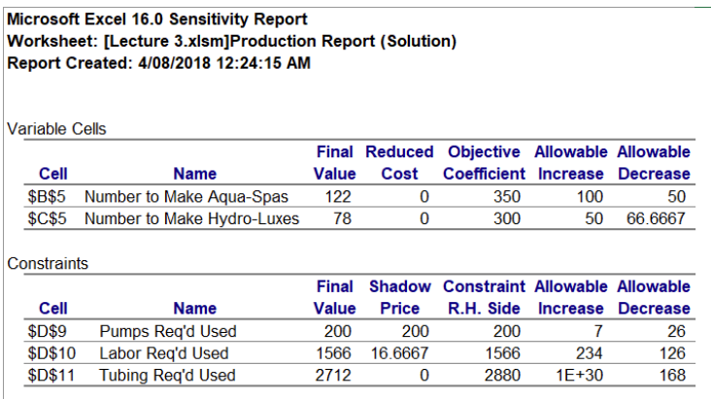

### variable cells section

说明每个目标函数系数在不影响最优解的情况下的变化量——假设所有其他系数保持不变

* What happens when we change the values of the coefficients in the objective function
* What happens variables are not part of the optimal solution
* Note: Values of zero (0) in “Allowable Increase” or “Allowable Decrease” columns for the Changing Cells indicate that an alternate optimal solution exists

### constraints section

* What happens to the value of the objective function if we increase (or decrease) available resources?
* “Allowable Increase” and “Allowable Decrease” the amounts by which an objective function coefficient can change without changing the optimal solution
* 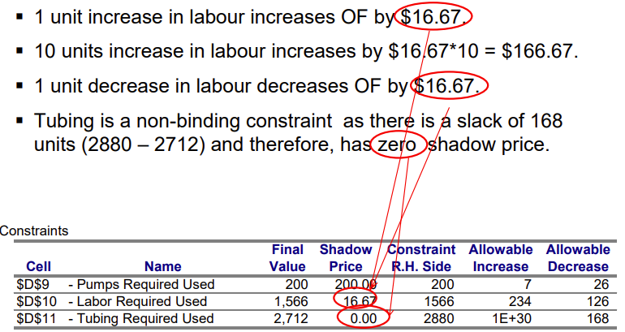

#### Binding vs non-Binding

* Binding constraint:
  + A change in RHS value changes the feasible solutions & optimal solution. You have to re-solve model to find new optimal solution (the report does not tell you this!)
* Non-binding constraint:
  + The shadow price is always zero (adding more of a resource not been used up is no help)

## Constraint RHS Values

Shadow price of a constraint indicates the amount by which the objective function value changes given a unit increase in the RHS value of the constraint, assuming all other coefficients remain constant.

Changing a RHS value for a binding constraint also changes the feasible region and the optimal solution

shadow price is the revenue that is sacrificed to enforce the constraint

## Shadow prices

* Shadow prices of a resource you are currently paying for between which you would be willing to pay to get an additional unit of that resource
* Shadow prices holds if RHS value of constraint falls within allowable Increase or Decrease values.
* Resources in excess supply (not blinding) have a shadow price (or marginal value) of zero
* 影子价格越大表示这种资源相对紧缺，反之影子价格越小表示这种资源相对不紧缺。影子价格是0就表示这种资源处于过剩状态
* 调整一个约束右边常数项时候，目标函数的变化率
* 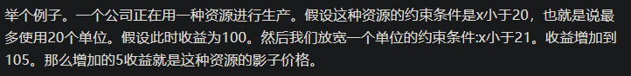
* 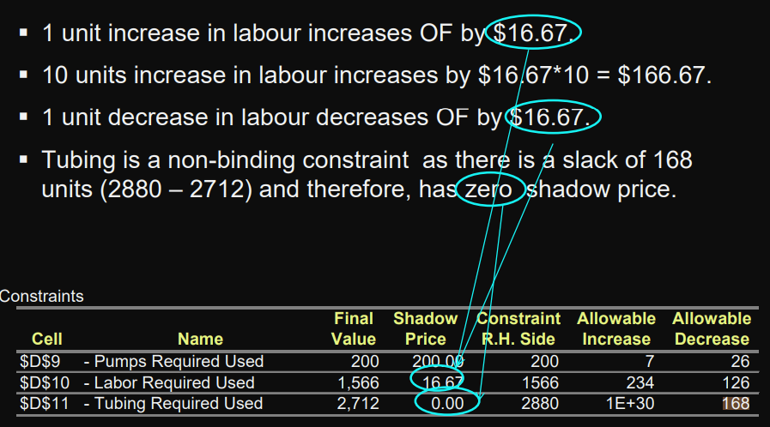

### Reduced Costs

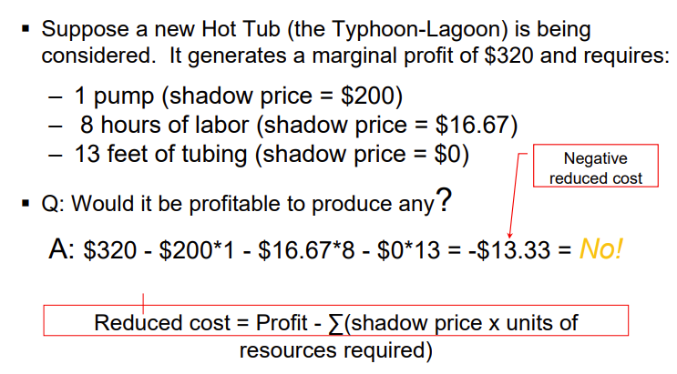

* The reduced cost for each product equals its per-unit marginal profit minus the per-unit value of the resources it consumes (priced at their shadow prices).
* Products whose marginal profits are less than the marginal value of the goods required for their production will not be produced in an optimal solution (unless a constraint forces the product to be produced)
* Reduced costs tell us by how much we would have to increase the profitability of an item before it would be included in the optimal solution (for a maximisation problem). And vice-versa for a minimisation problem.

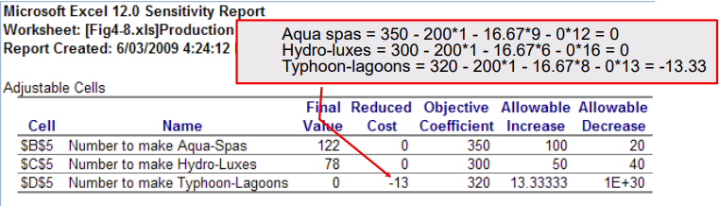

### Degeneracy

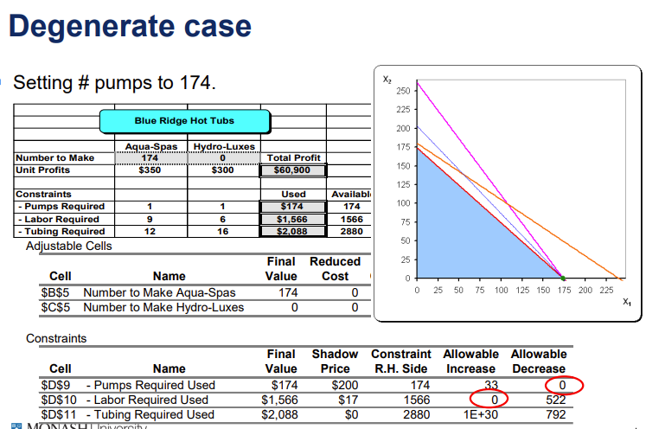

* The solution to an LP problem is degenerate if the Allowable Increase or Decrease on any constraint is zero (0).
* When the solution is degenerate:
  + The methods mentioned earlier for detecting alternate optimal solutions cannot be relied upon.
  + The reduced costs for the changing cells may not be unique. Also, the objective function coefficients for changing cells must change by at least as much as (and possibly more than) their respective reduced costs before the optimal solution would change
  + The allowable increases and decreases for the objective function coefficients still hold and, in fact, the coefficients may have to be changed beyond the allowable increase and decrease limits before the optimal solution changes
  + The given shadow prices and their ranges may still be interpreted in the usual way but they may not be unique. That is, a different set of shadow prices and ranges may also apply to the problem (even if the optimal solution is unique!)

## Limits report

Summarises the value of the objective function as each variable cell ranges through its limits

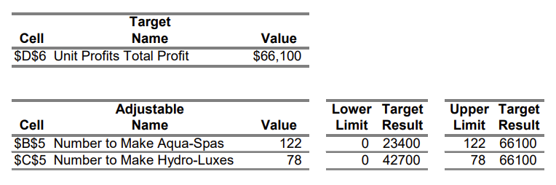

## The Simplex Method

we first convert all inequalities to equalities by adding slack variables to <= constraints and subtracting slack variables from >= constraints

* Identify any basic extreme point for an LP problem, then moving to an adjacent extreme point if such a move improves the value of the objective function.
* Moving from one extreme point to an adjacent one occurs by switching one of the basic variables with one of the nonbasic variables to create a new basic feasible solution (for an adjacent extreme point).
* When no adjacent extreme point has a better objective function value, stop -- the current extreme point is optimal.

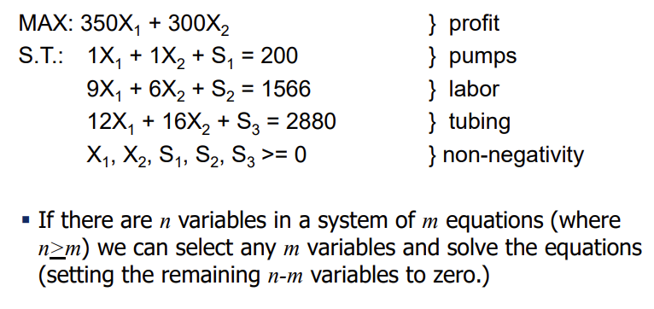 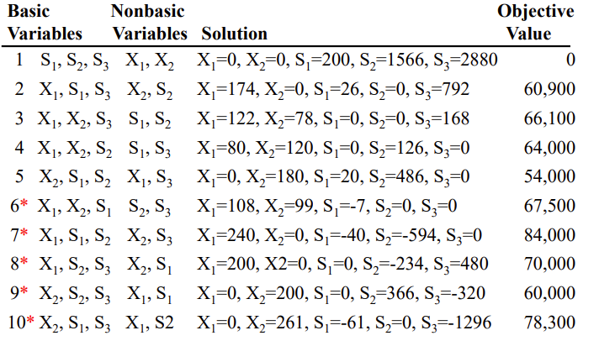 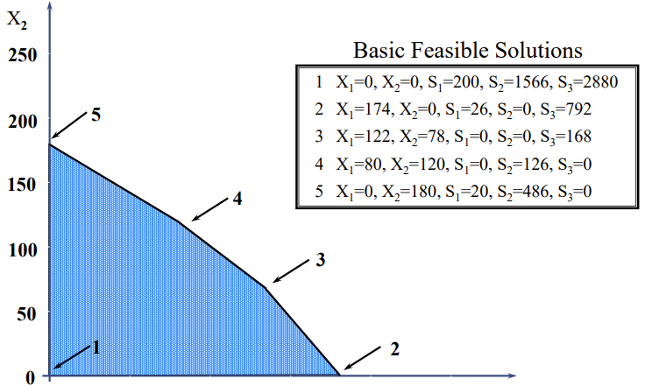

# W4(Integer Linear Programming)

## Integer Linear Programming (ILP)

– When one or more variables in an LP problem must assume an integer value

occur frequently：

* Scheduling workers
* Manufacturing products

allow us to build more accurate models：

* Quantity discounts
* Setup and lump sum costs
* Batch size restrictions

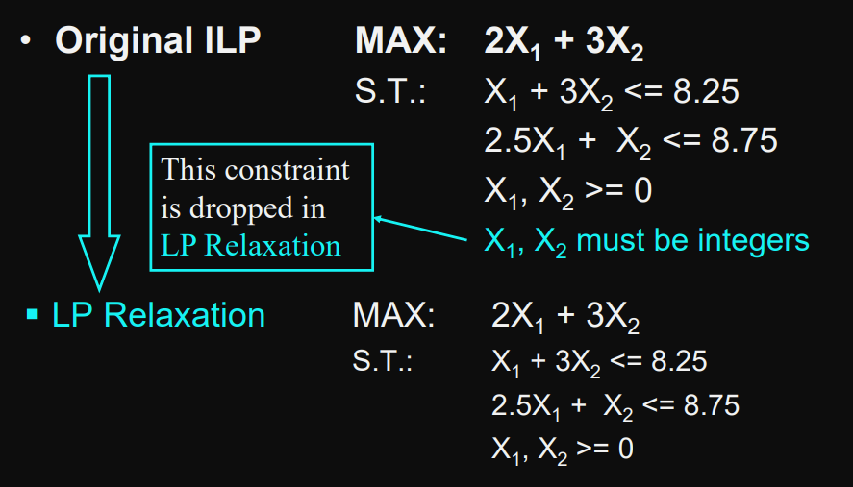

## Method:

### Bounds

optimal solution to an LP relaxation of an ILP problem gives us a bound on the optimal objective function value

* maximization problems, optimal relaxed objective function values is an upper bound on the optimal integer value
* minimization problems, relaxed objective function values is a lower bound on the optimal integer value.

### Rounding

does not work reliably:

* solution may be infeasible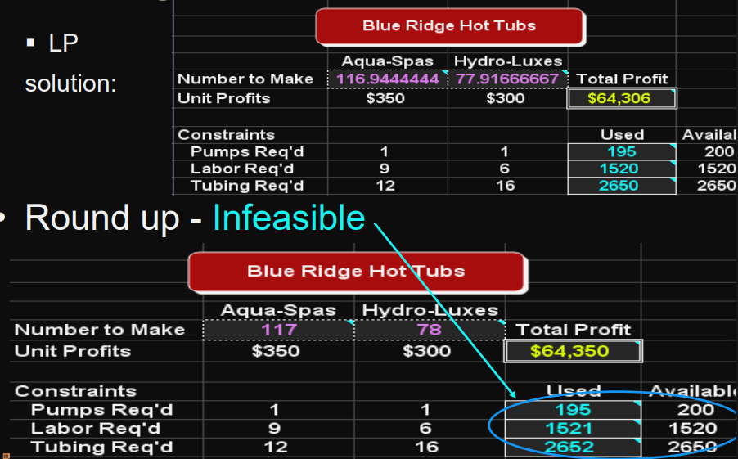
* solution may be suboptimal. 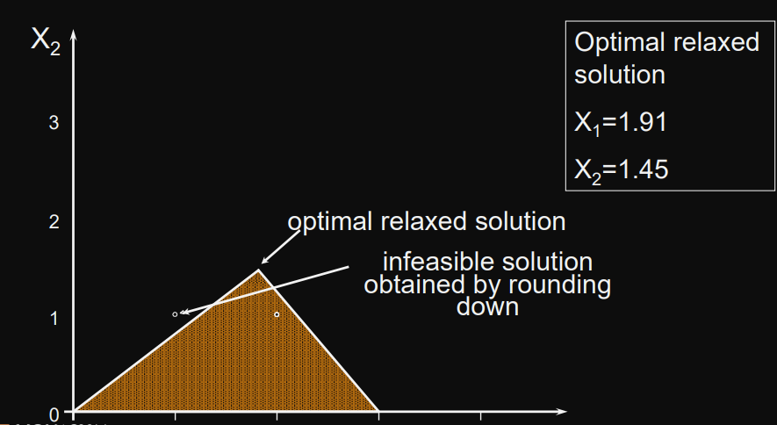

### Branch-and-Bound

Theoretically, this can solve any ILP, but it often takes LOTS of computational effort

But most ILP packages allow you to specify a sub-optimality tolerance factor.

* stop once an integer solution is found that is within some %
* eg. 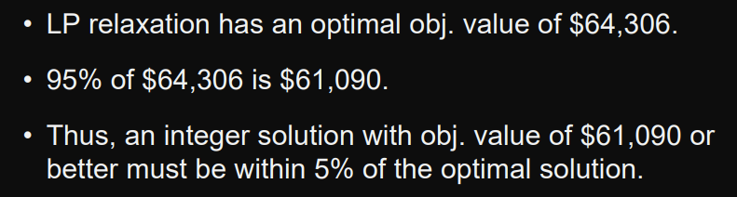

# Practise in Excel:

## Using Solver

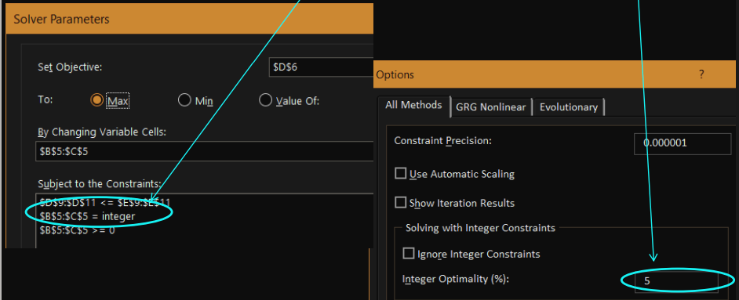

## Binary Variables

only two values: 0 or 1

Binary variables are also useful in modelling a number of logical conditions.

* 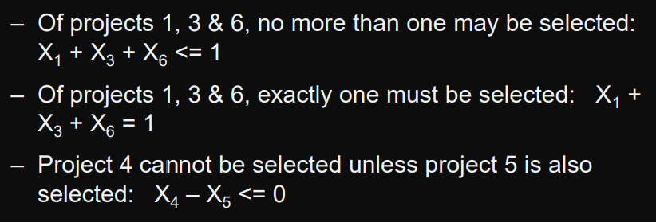

## An Employee Scheduling Problem

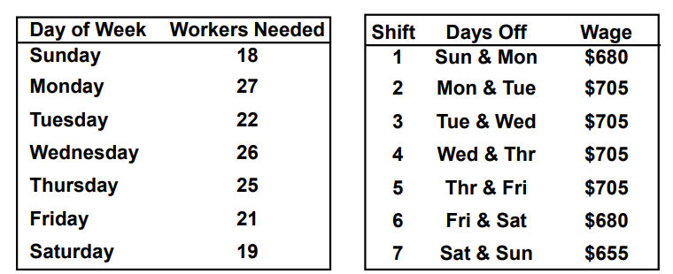 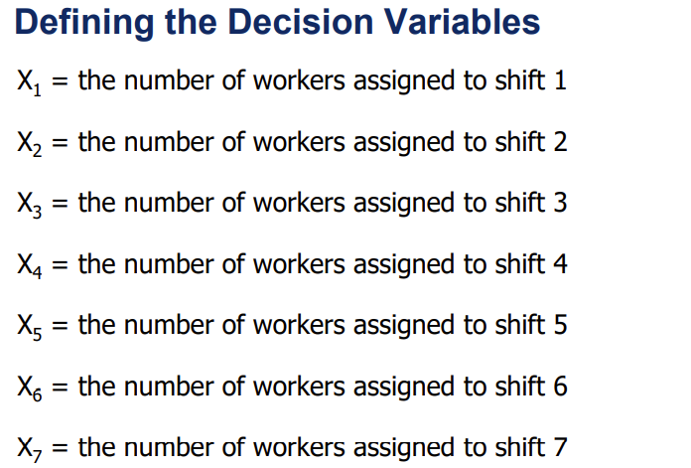 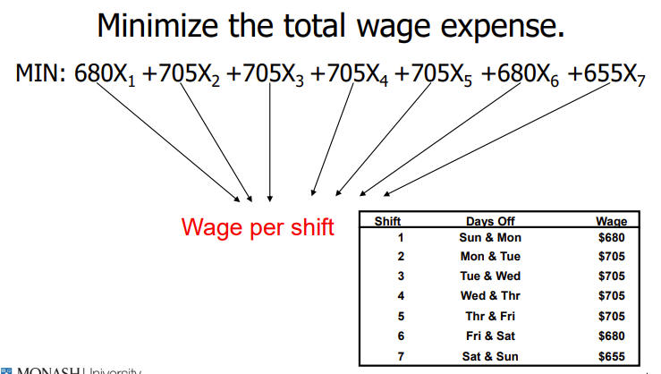 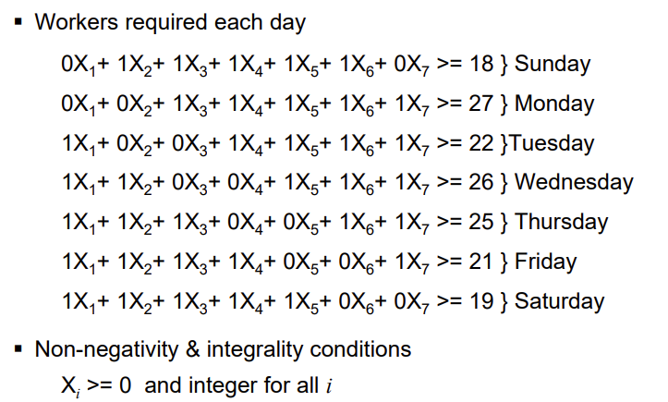 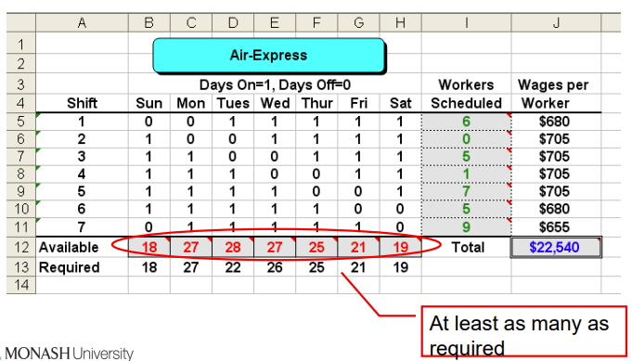

## A Capital Budgeting Problem:

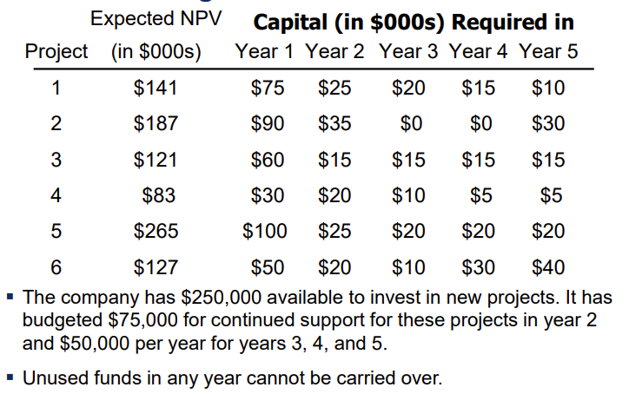 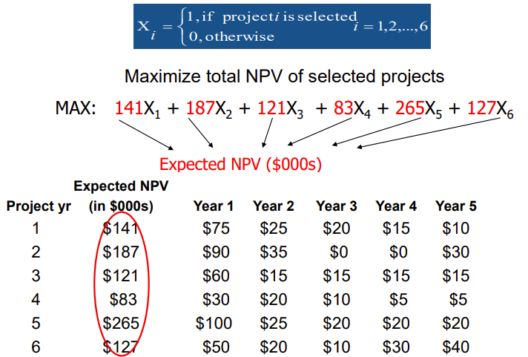 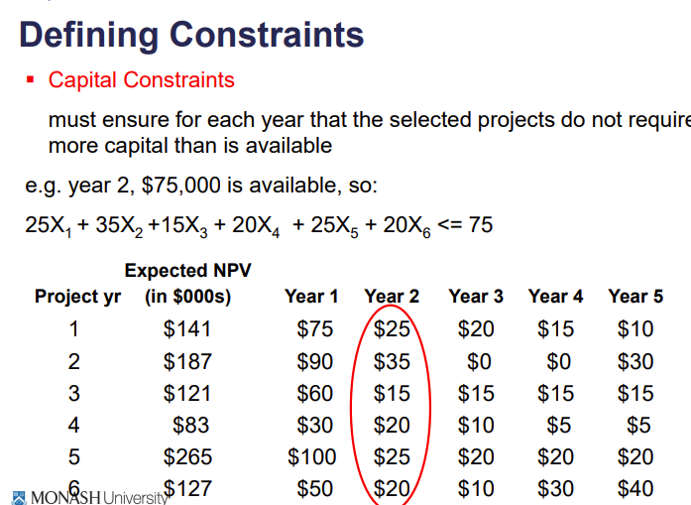 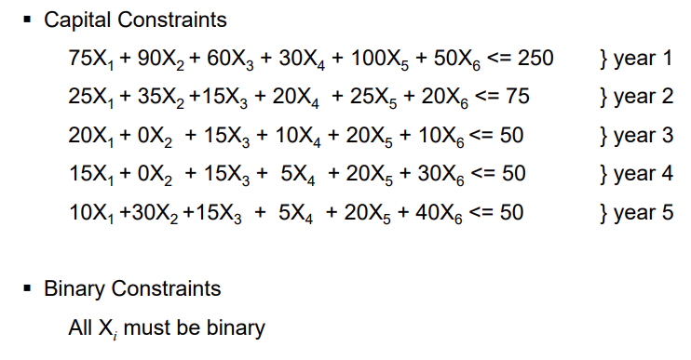 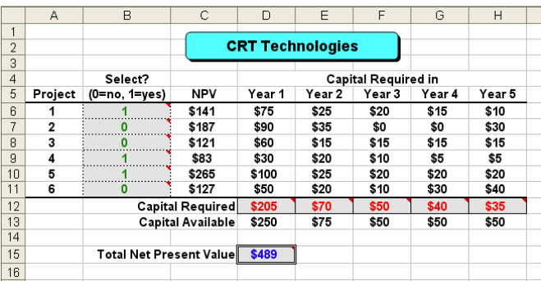

## The Fixed-Charge Problem

* cost to lease, rent, or purchase a piece of equipment or a vehicle that will be required if a particular action is taken
* setup cost required to prepare a machine or to produce a different type of product
* cost to construct a new production line that will be required if a particular decision is made.
* The cost of hiring additional personnel that will be required if a particular decision is made

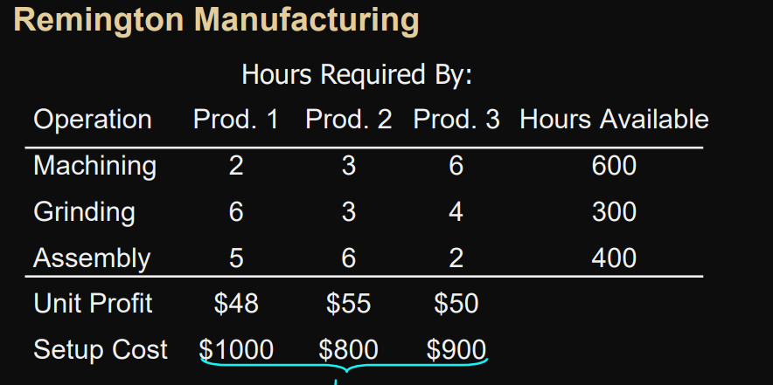

we need to ensure that Yi =1 if Xi >0

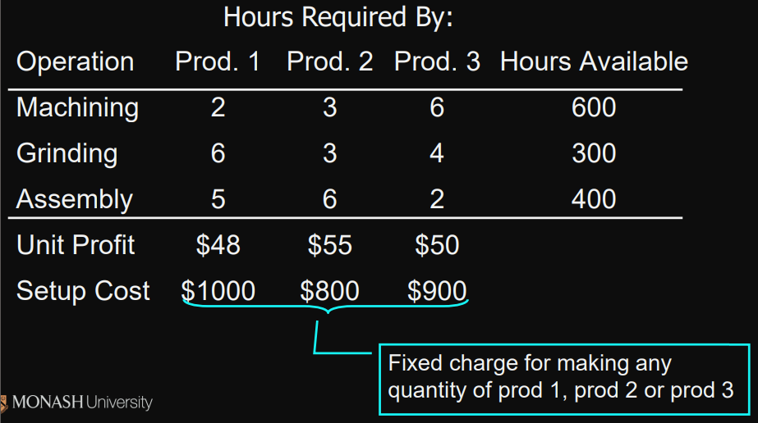

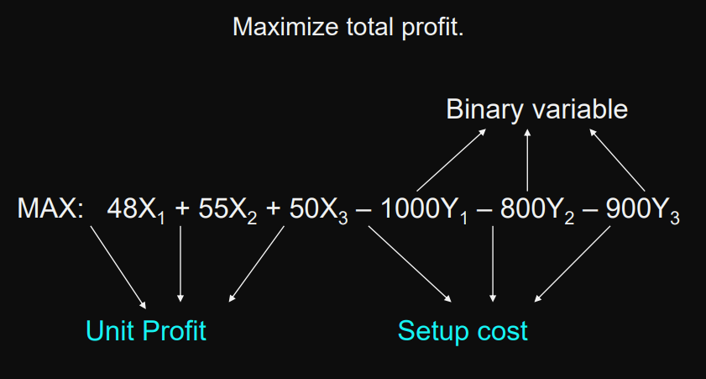

Defining the Constraints

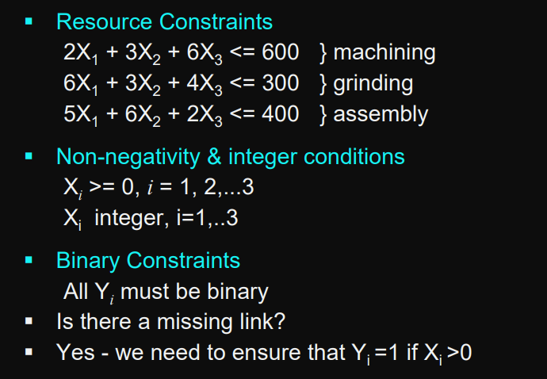

Linking Constraints

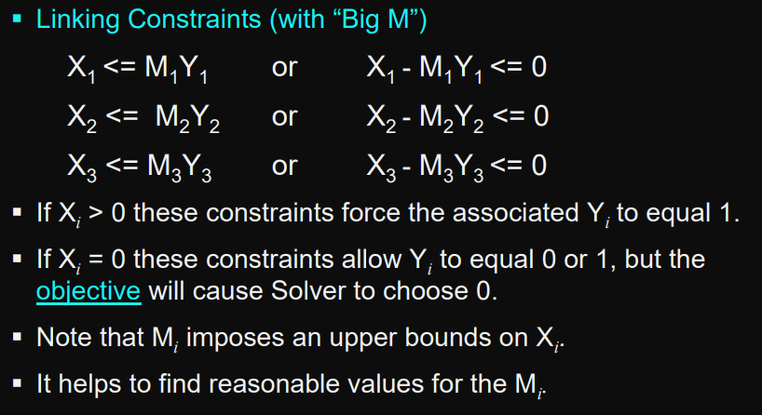 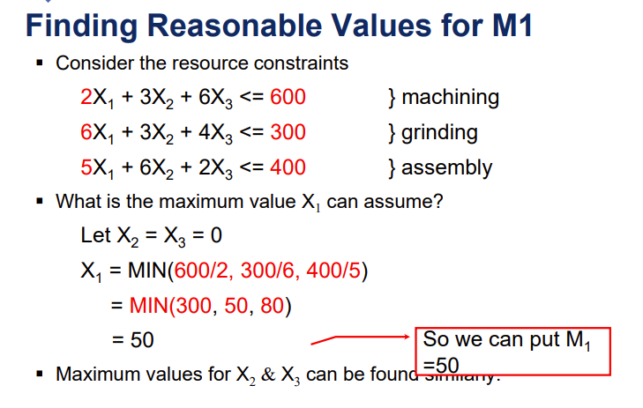

Summary

Don’t use IF function

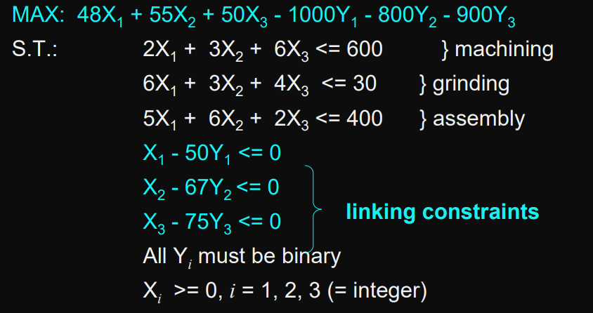 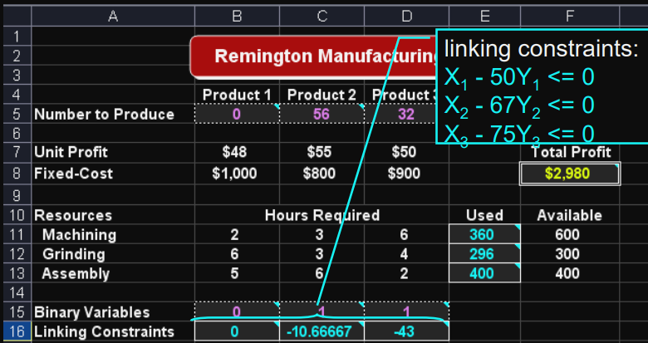

### Warning:

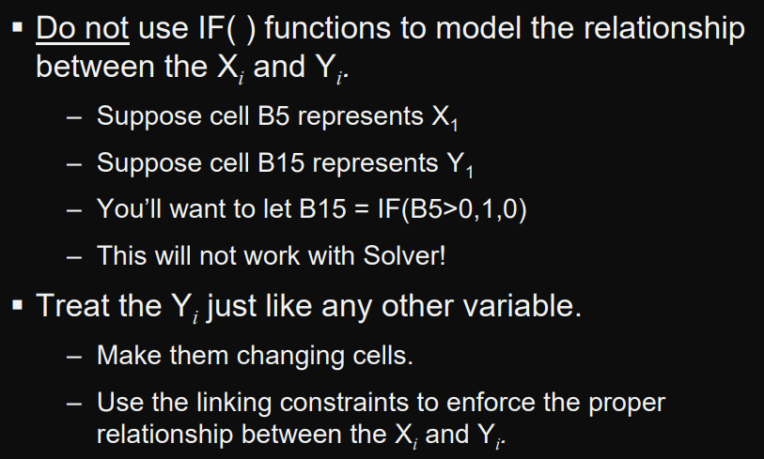

## Minimum Order Size Restrictions

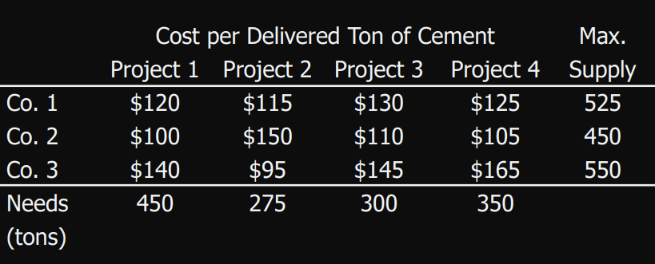

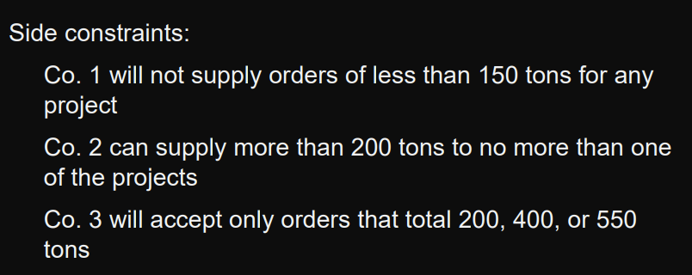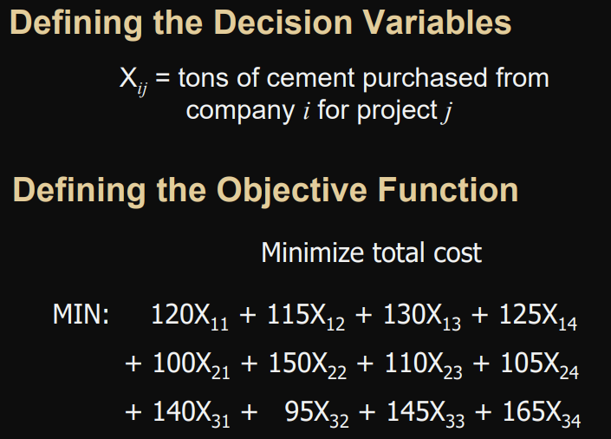 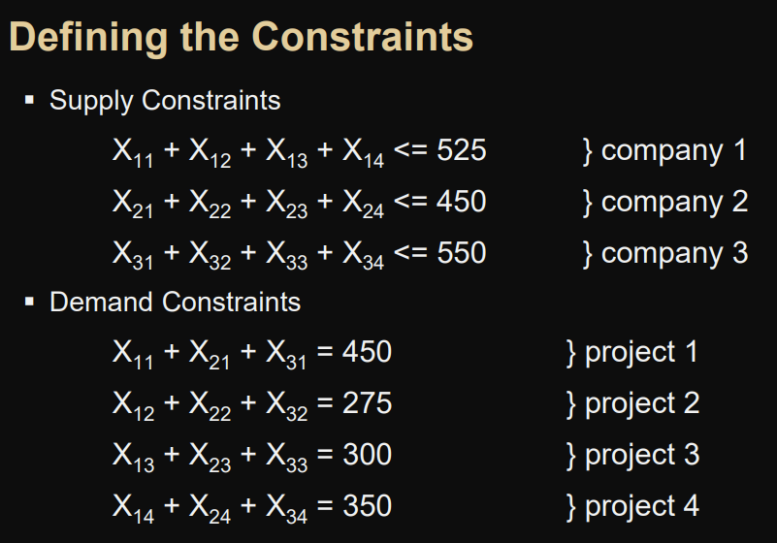

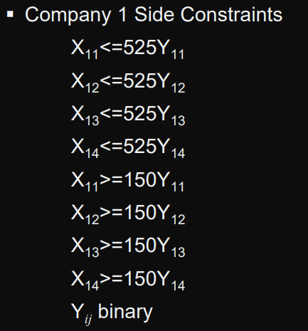 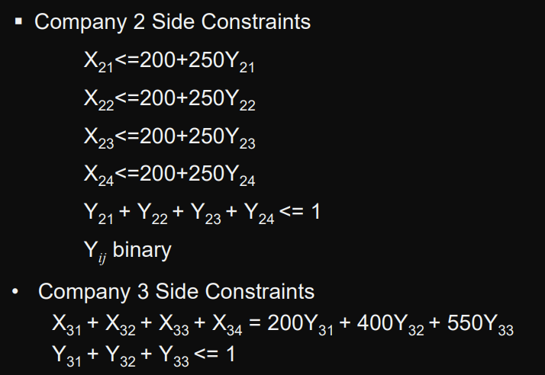

# W5

## Network Flow Problem Characteristics

represented as a collection of nodes connected by arcs

three types of nodes: Supply – Demand – Transhipment

## Transshipment Problem

* transportation problems in which a shipment may move through nodes (transhipment nodes) before reaching a particular destination node
* Transhipment problems can be converted to larger transportation problems and solved by a special transportation program
* network representation with two sources, three intermediate nodes, and two destinations
* 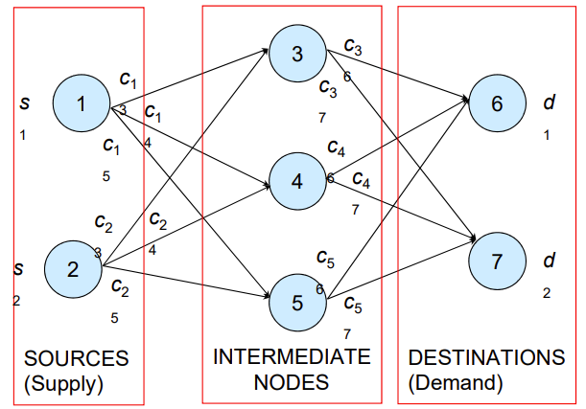

### Example

The Bavarian Motor Company

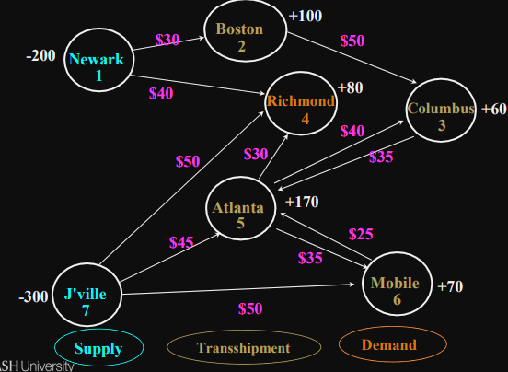

Decision Variables

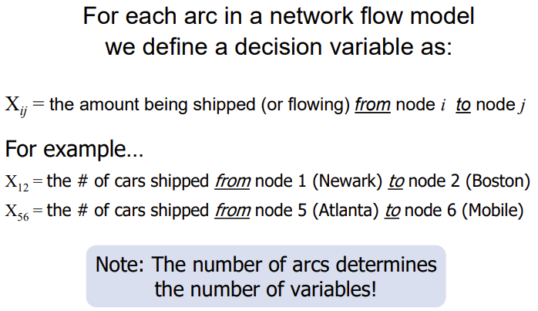

Defining the Objective Function

Minimize cost

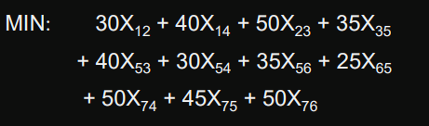

Defining the Constraints

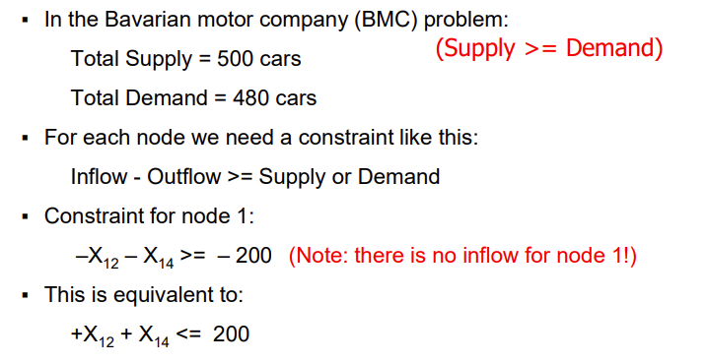 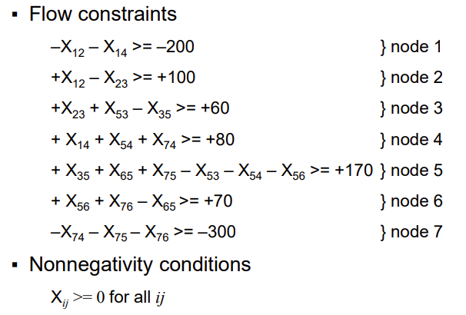

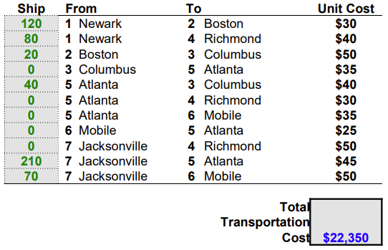

## The Shortest Path Problem

determining the shortest route or path through a network.

-Example: Emergency Vehicle Routing

This is a special case of a transhipment problem where:

* There is one supply node with a supply of -1
* There is one demand node with a demand of +1
* All other nodes have supply/demand of +0

### Algorithm

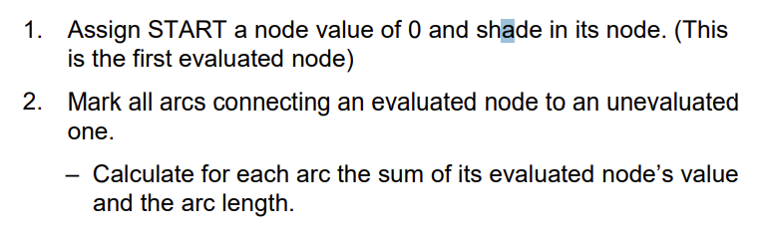 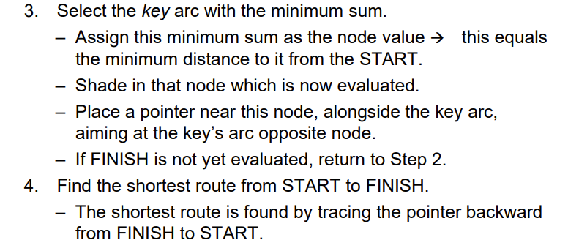 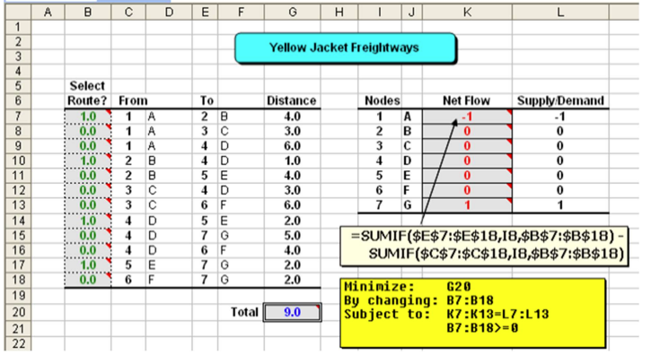

## Generalised Network Flow Problems

gain or loss occurs in flows over arcs

– Example: Oil or gas shipped through a leaky pipeline

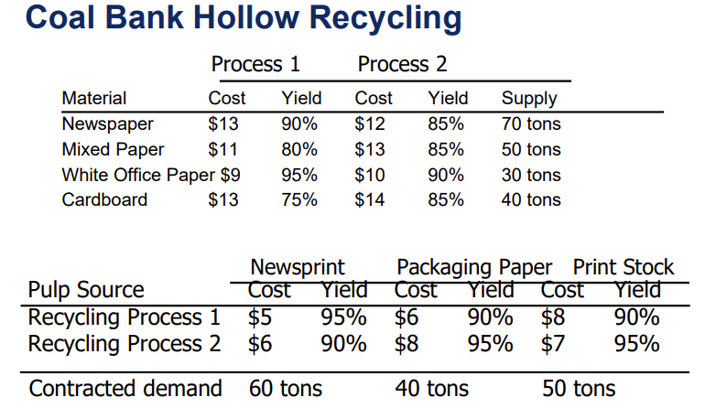 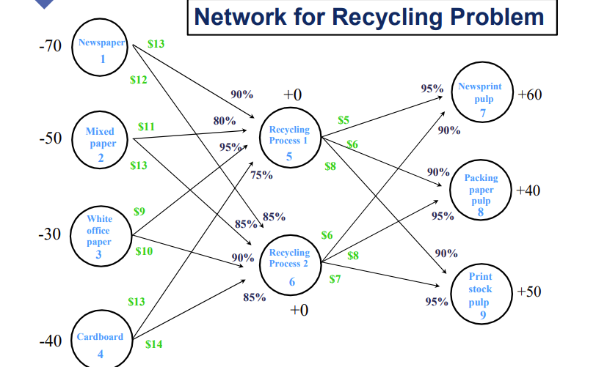 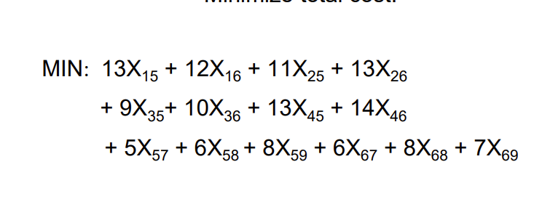 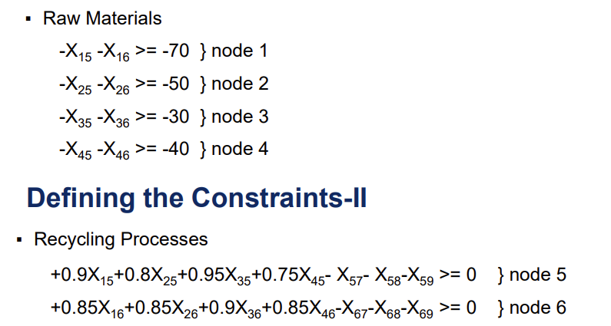 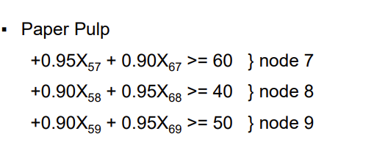 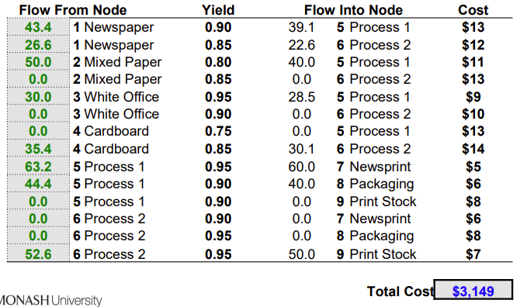

### Important Modelling Point

* This can make it difficult to tell if the total supply is adequate to meet the total demand.
* In generalised network flow problems, gains and/or losses associated with flows across each arc effectively increase and/or decrease the available supply.
* it is best to assume the total supply is capable of satisfying the total demand and use Solver to prove (or refute) this assumption.
* If all the demand can’t be met, another objective might be to meet as much of the demand as possible at minimum cost. To do this
  + Add an artificial supply node with an arbitrarily large amount of supply
  + Connect the artificial supply node to each demand node with arbitrarily large costs on each artificial arc.
  + This causes as much demand as possible to be met using real supply to minimize use of the expensive artificial supply.

## Maximal Flow Problem

determine the maximum amount of flow that can occur through a network

— Examples: How much water can flow through a network of pipes?

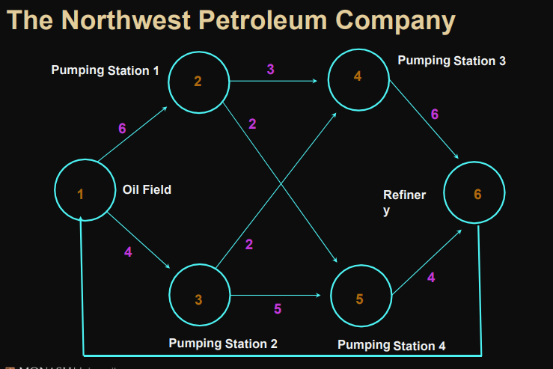

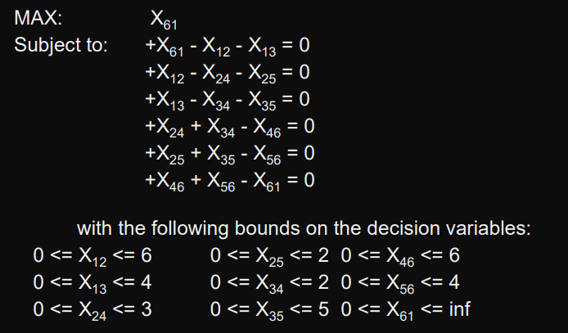

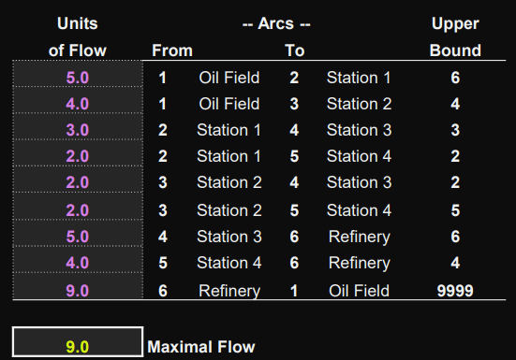 b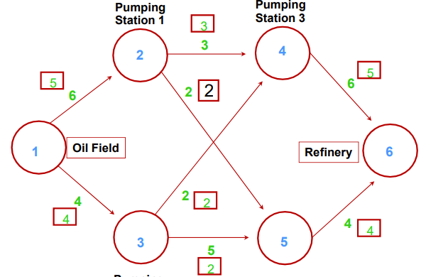

### Special Modelling- Flow Aggregation

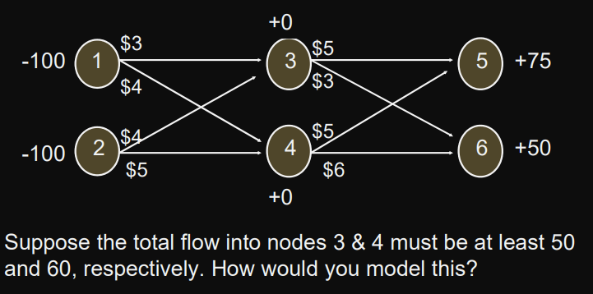

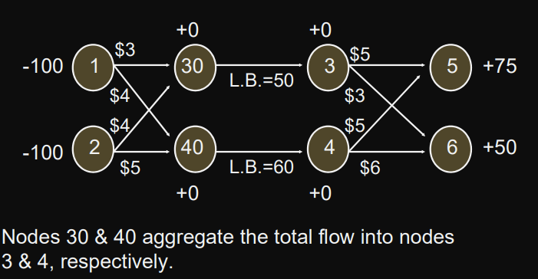

### Special Modelling- Multiple Arcs Between Nodes

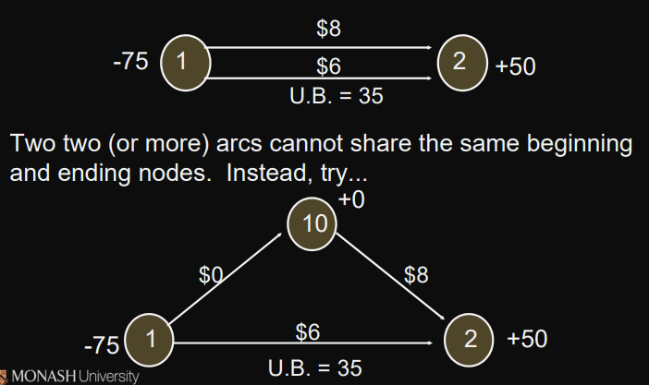

### Special Modelling- Capacity Restrictions on Total Supply

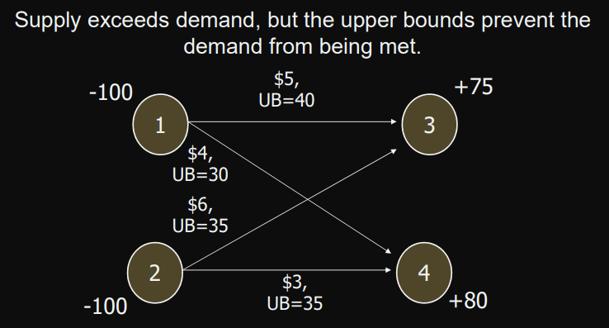

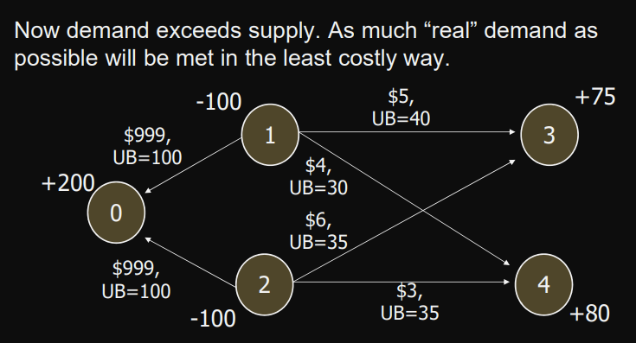

## Minimal Spanning Tree Problem

* n nodes, a spanning tree is a set of (n-1) arcs that connects all the nodes and contains no loops
* determining the set of arcs that connects all the nodes at minimum cost
* normally not use all arcs in the original network
* cannot be solved as an LP problem. However, easily solved using a manual algorithm
* Algorithm
  + Select any node
  + Add cheapest arc

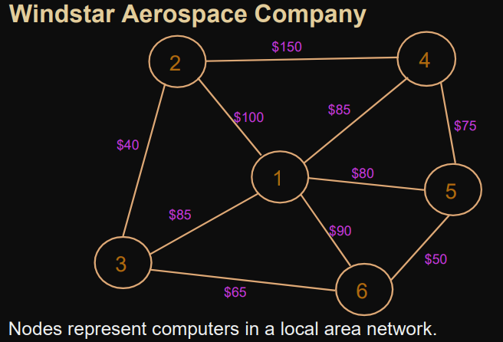

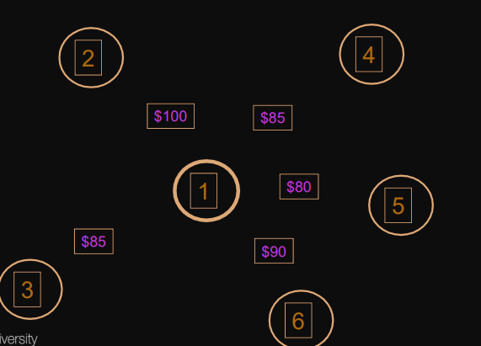

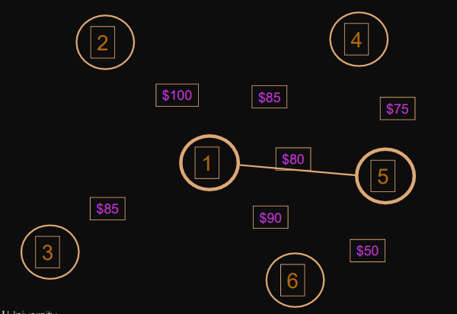

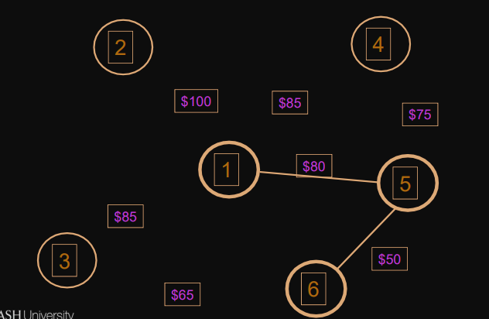

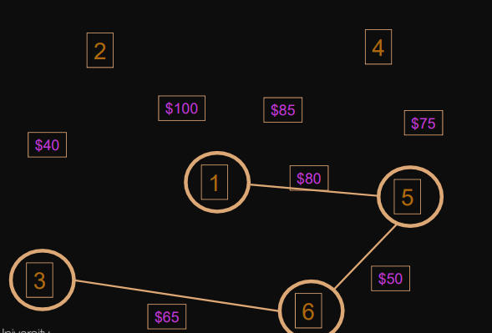

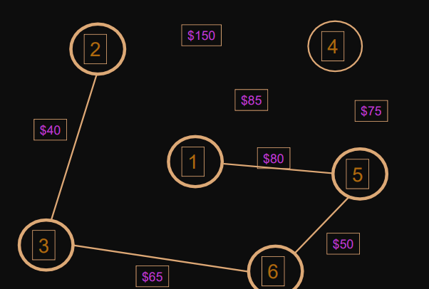

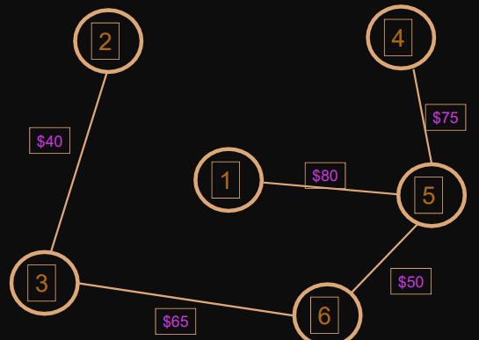

# W6

## Network Modelling

represented by a set of nodes, a set of arcs(edges), and functions

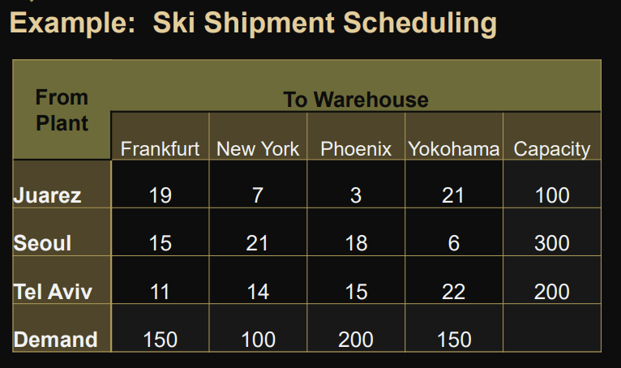

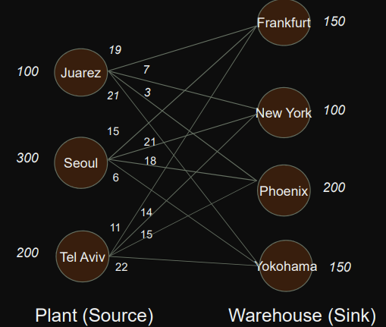

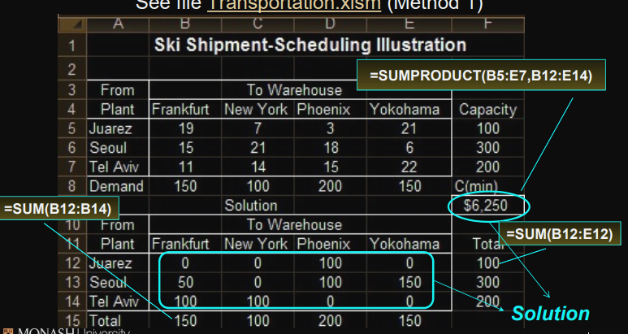

## Method:

### Northwest Corner Method

Easy for calculating manuall y

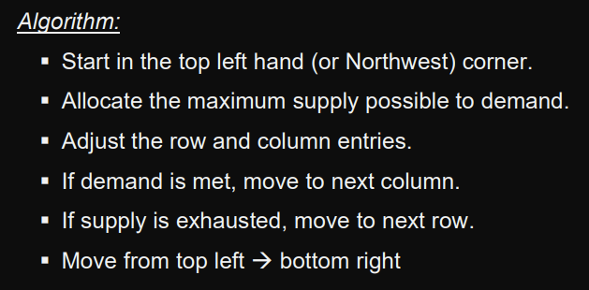 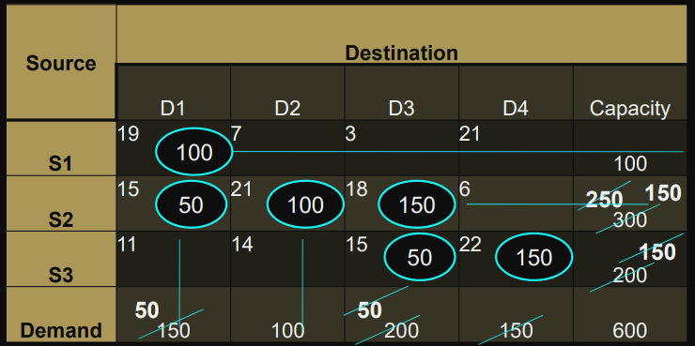 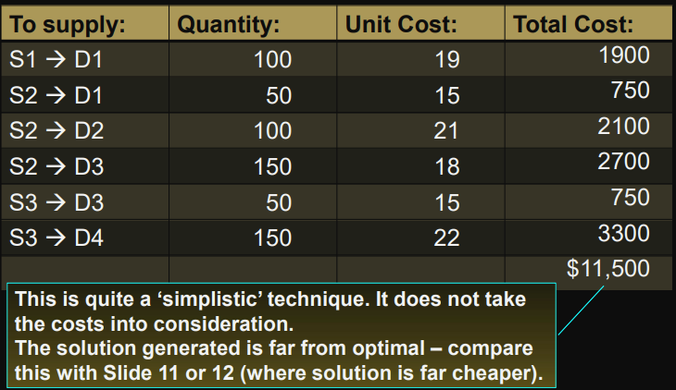

### Vogel’s Approximation Method (VAM)

* used for ammunition distribution
* Try to avoid high-cost routes
* Will be implicitly making decisions about alternative routes.
* not only consider direct costs
* 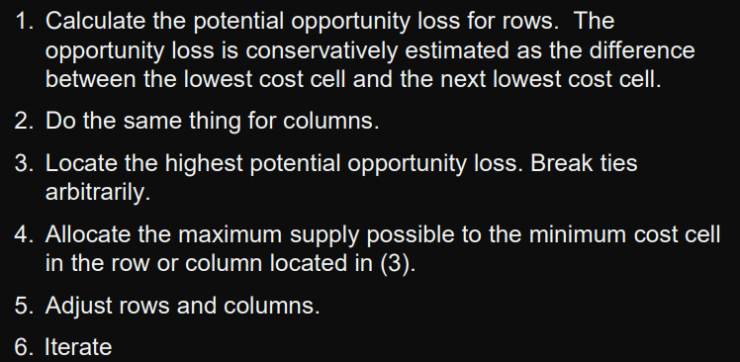 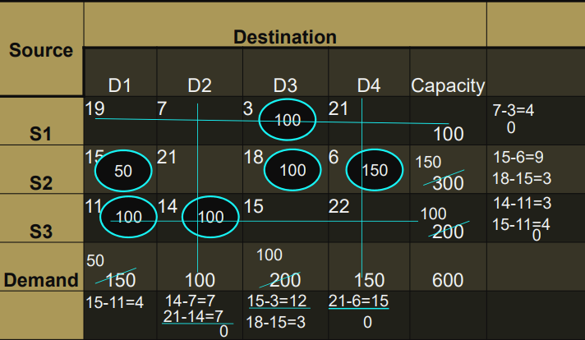 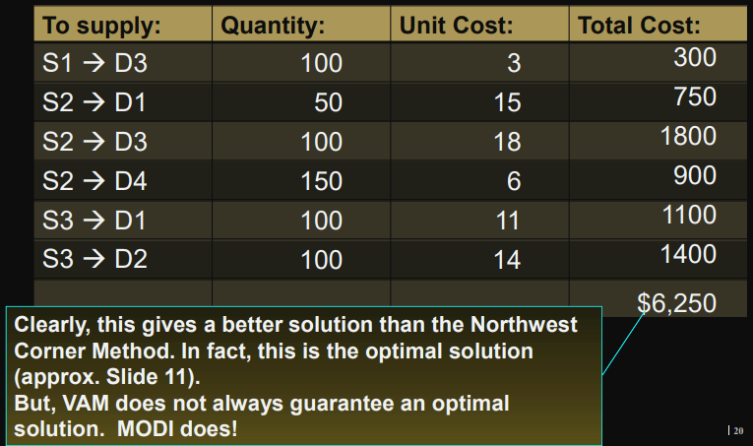

### MODI (The Closed-Loop Method)

Modified Distribution Method/ Modified Dantzig Iteration Algorithm

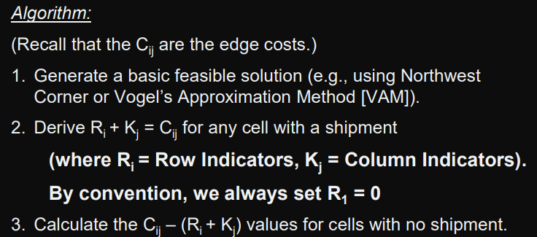 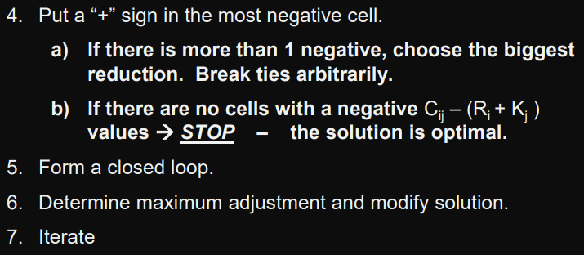

Start with NCM

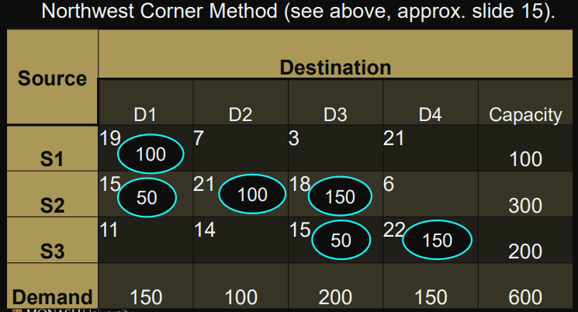 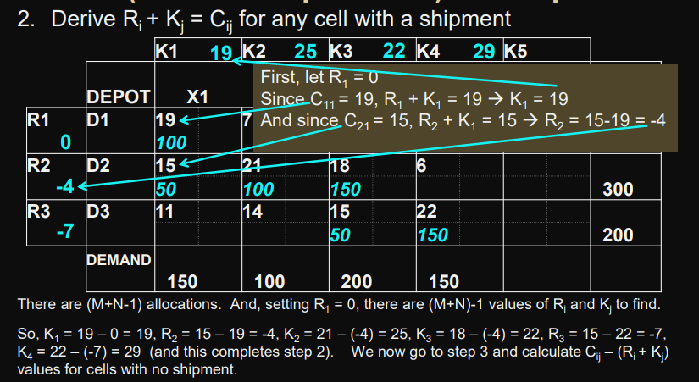 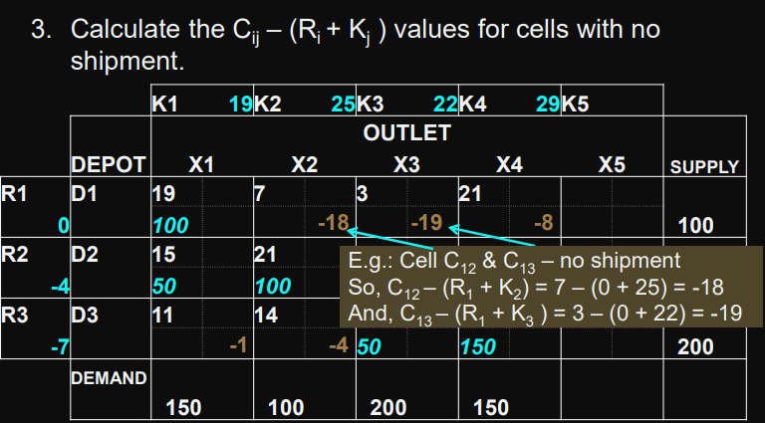 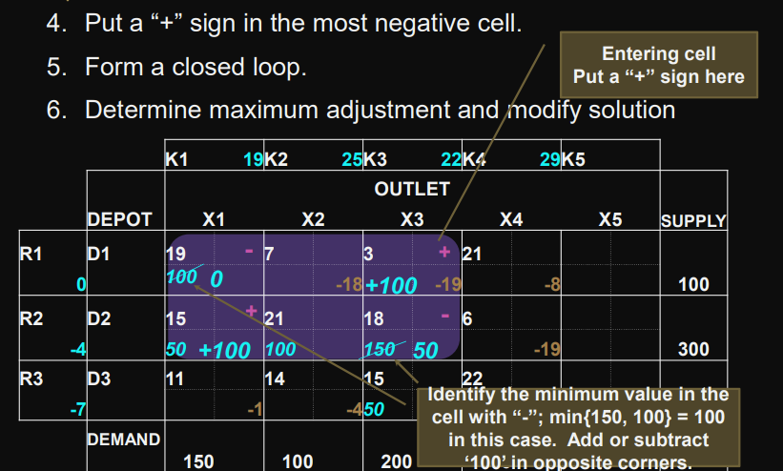 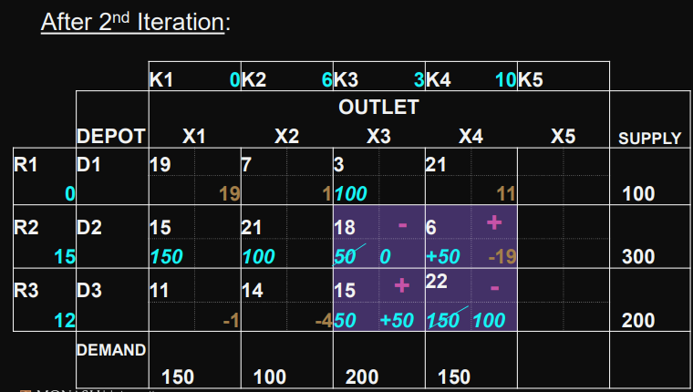 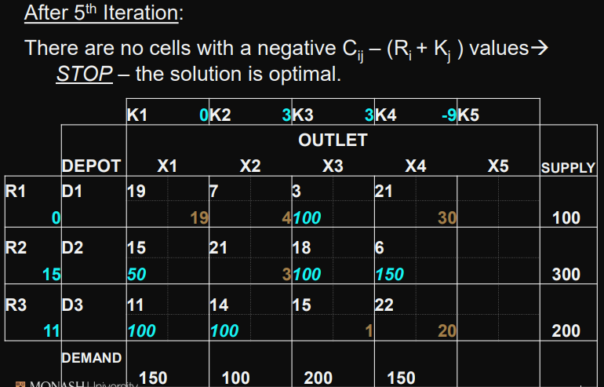 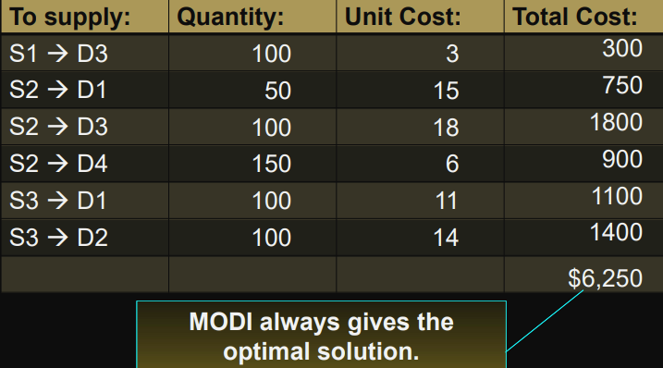

### Some issues to take note

* When supply does not equal demand
  + add a dummy column for demand to make up for the difference 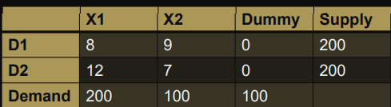
  + when demand > supply, add a dummy row for supply
  + the first step in doing any allocations is to check whether the demand and supply are equal
* When there’s a case of degeneracy
  + 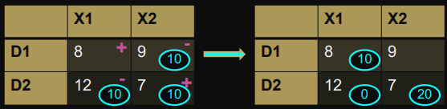
  + We now ended up having 2 allocations, thus breaking the (M + N – 1) rule.
  + we put a zero (0) in one of the cells.

# Assignment Problem

* minimize the total cost assignment of m workers to m jobs
* assumes all workers are assigned and each job is performed
* special case of a transportation problem in which all supplies and all demands are equal to 1; hence assignment problems may be solved as linear program

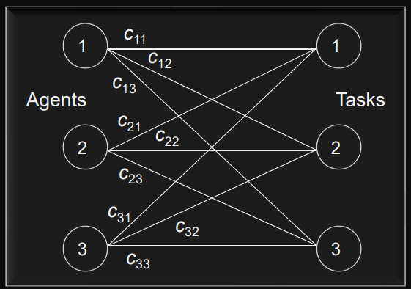

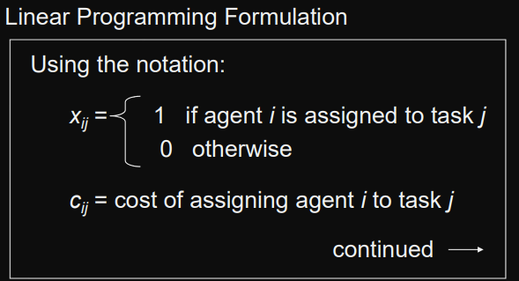 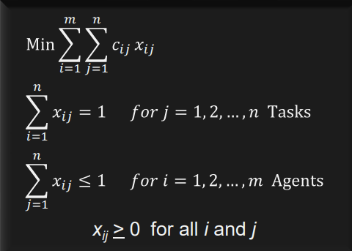

## Special Cases

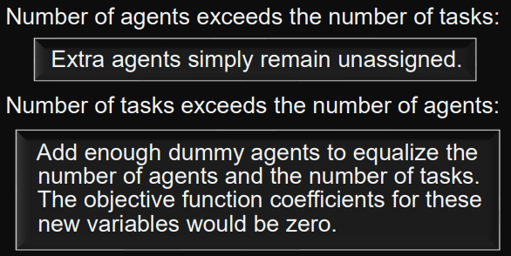 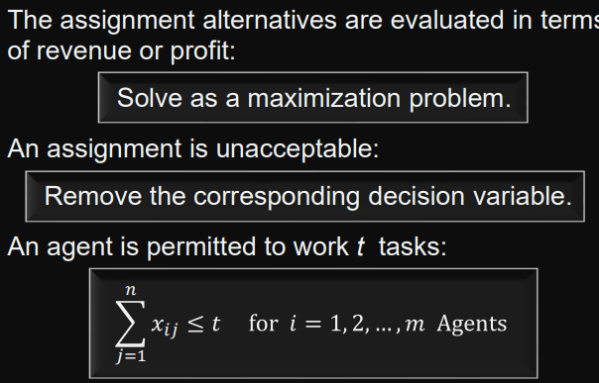

## Example

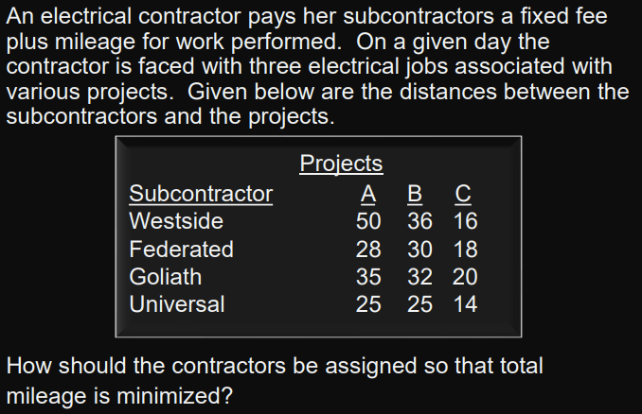 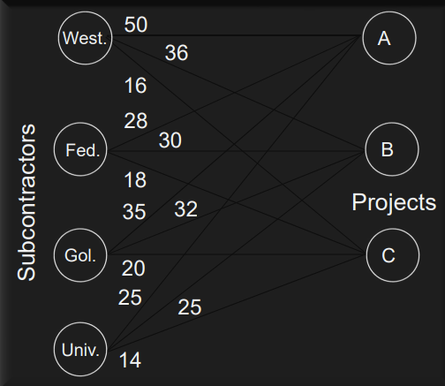 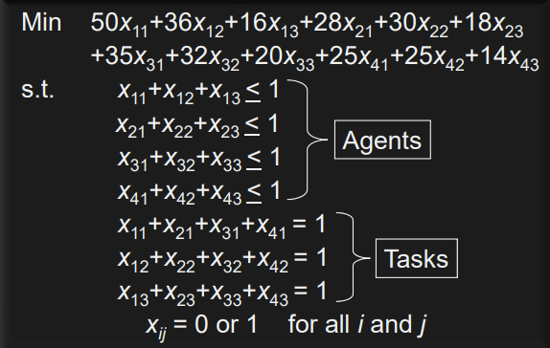 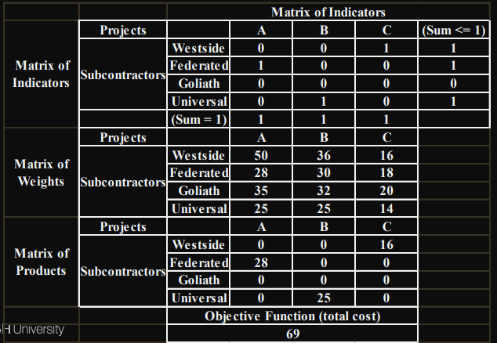 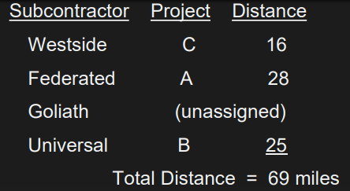

# W7

# Inventory Models

* How much should be ordered each time
* When should the reordering occur (How Often?)

The objective is to minimize total variable cost over a specified time period

# Inventory Costs

* Ordering cost
  + salaries and expenses of processing an order
* Holding cost
  + percentage of the value of the item assessed for keeping an item in inventory
  + eg: finance costs, insurance, security costs, taxes, warehouse overhead
* Backorder cost
  + costs associated with being out of stock when an item is demanded e,g.lost goodwill or lost sales
* Purchase cost
  + the actual price of the items

# Economic Order Quantity (EOQ)

* Simplest models assume demand and the other parameters of the problem to be deterministic and constant (确定性和持续性), also it is most basic of the deterministic inventory models
* variable costs in this model are annual holding cost and annual ordering cost
* EOQ, the annual holding and ordering costs are equal

## Problem

Involves determining the optimal quantity to purchase when orders are placed

Small orders:

* low inventory levels & holding costs
* frequent orders & higher ordering costs

Large orders:

* higher inventory levels & holding costs
* infrequent orders & lower ordering costs

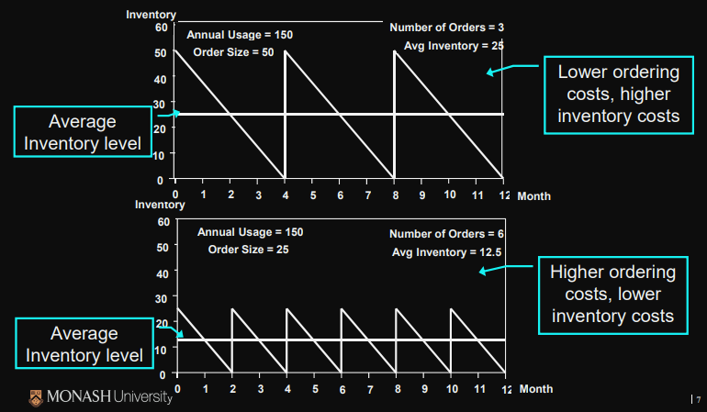

## Assumptions

* Demand is constant throughout the year
* Purchase cost per unit is constant
* Delivery time (lead time) is constant
* Planned shortages are not permitted
* when all of the assumptions of the economic order quantity (EOQ) do not hold, the model may still be used as a good guide to ordering.

## Relationships

the quantity of stock to be ordered which minimises the total (annual) cost of holding and purchasing stock when the demand for goods is constant

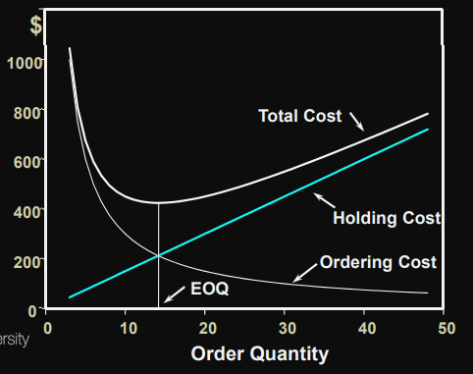

## Derivation

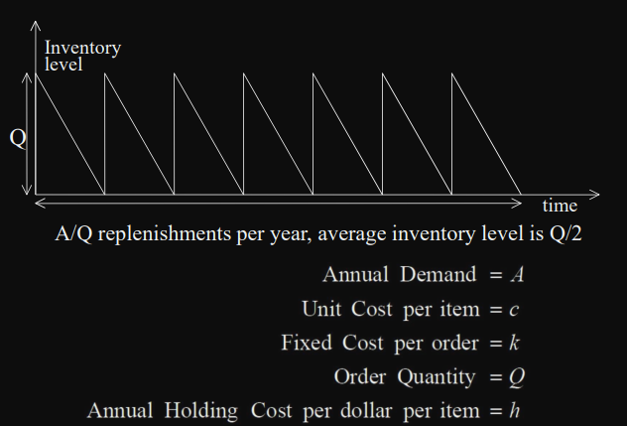 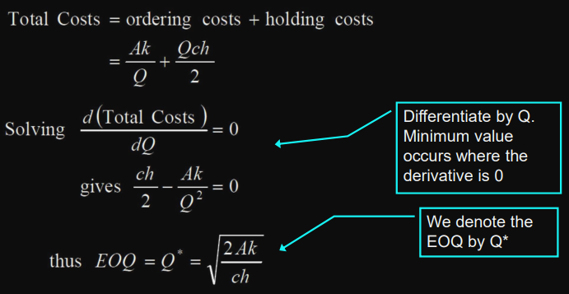

## Formulae

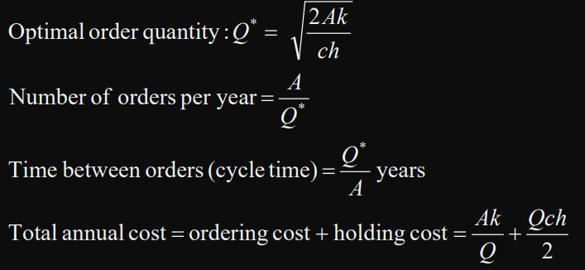

## Example 1

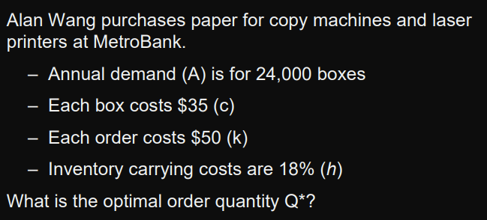 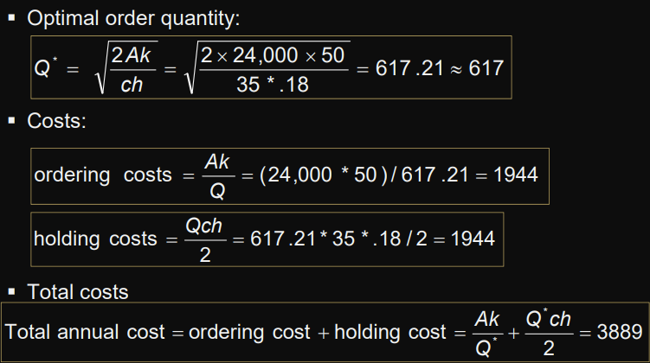

change the order quantity to 600? Very little change in Total Costs, but perhaps more convenient

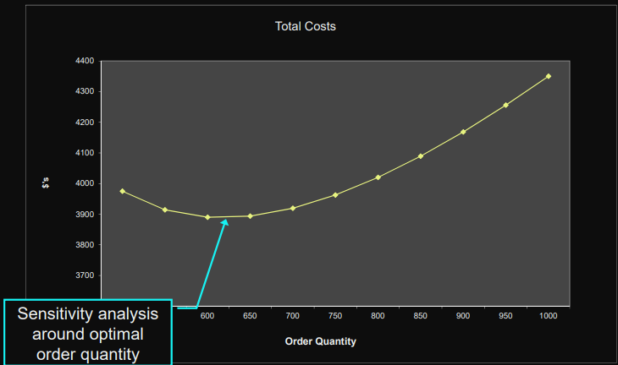

## Example 2

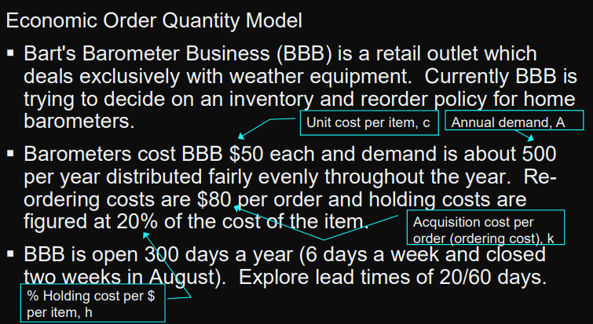 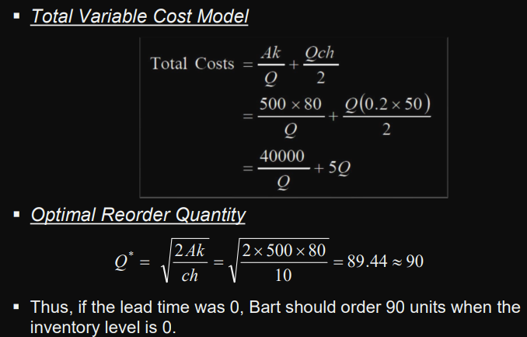 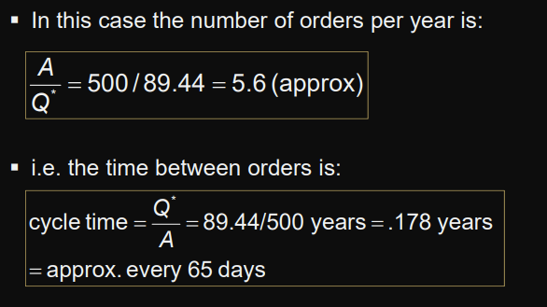 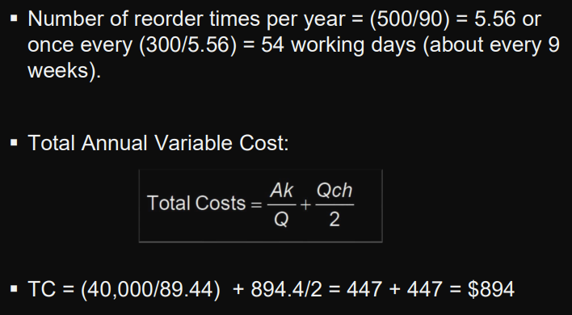 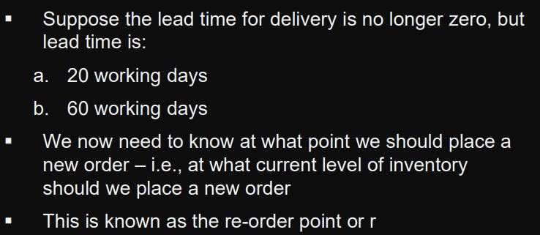 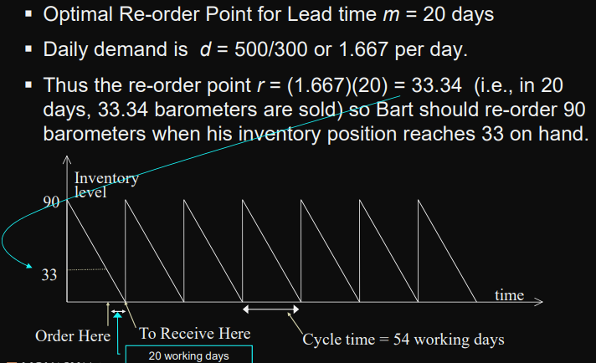 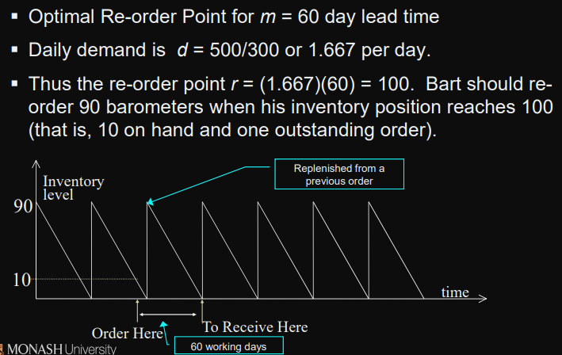 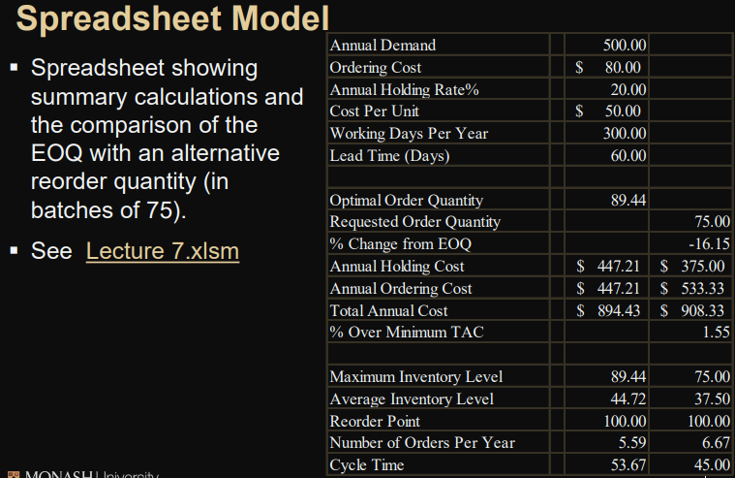

Summary

* A 16.15% negative deviation from the EOQ resulted in only a 1.55% increase in the Total Annual Cost.
* Annual Holding Cost and Annual Ordering Cost are no longer equal.
* The Re-order Point is not affected, in this model, by a change in the Order Quantity.

## EOQ Planned Shortages

* With the EOQ with planned shortages model, replenishment order does not arrive at or before the inventory position drops to zero
* Shortages occur until a predetermined back-order quantity is reached
* variable costs in this model are annual holding, backorder, and ordering.
* For the optimal order and back-order quantity combination, the sum of the annual holding and back-ordering costs equals the annual ordering cost

### Assumptions

* Demand occurs at a constant rate of A items per year
* Ordering cost: $k per order
* Holding cost: $ch per item in inventory per year
* Backorder penalty cost: $p per item back-ordered per year
* Purchase cost per unit is constant
* Set-up time (lead time) is constant

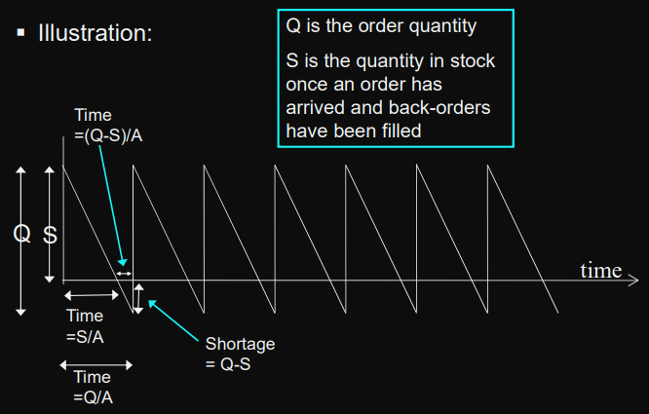

### Fomula

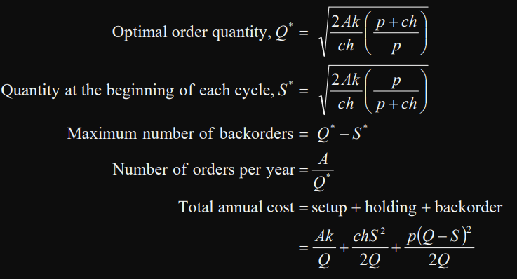

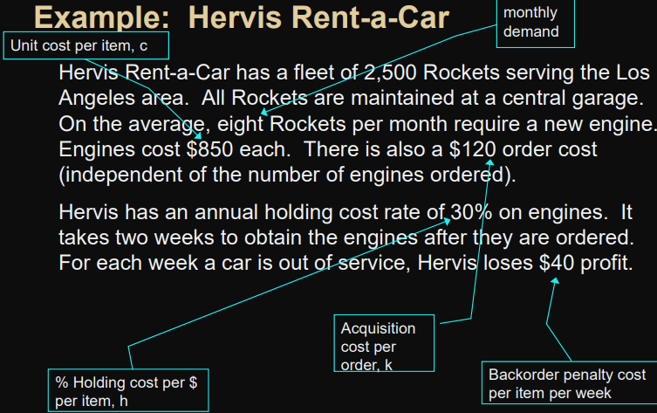 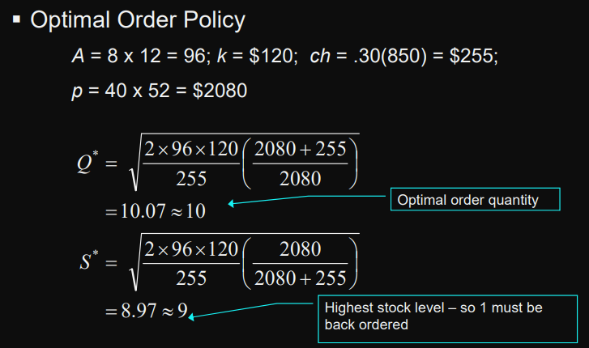 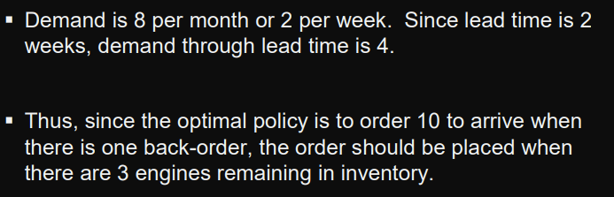 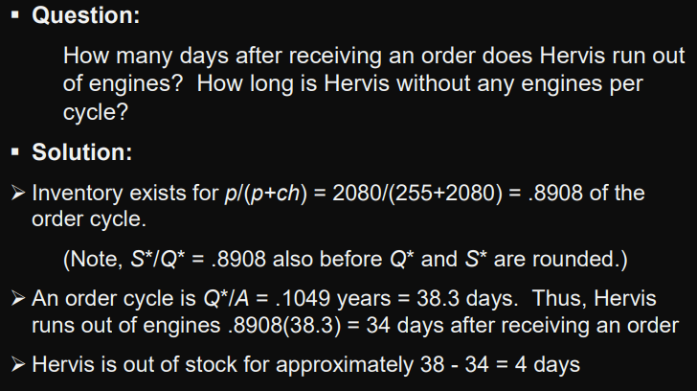

## EOQ with Quantity Discounts

* applicable where a supplier offers a lower purchase cost when an item is ordered in larger quantities
* model’s variable costs are annual holding, ordering and purchase costs
* the annual holding and ordering costs are not necessarily equal.

### Assumptions

* Demand occurs at a constant rate of A items per year
* Ordering Cost is $k per order.
* Holding Cost is h. This is equivalent to $ch per item in inventory per year as per previous models.
* Purchase Cost is
  + $c1 per item if the quantity ordered is between 0 and x1 ,
  + $c2 if the order quantity is between x1 and x2
* Delivery time (lead time) is constant.
* Planned shortages are not permitted

### Formulae

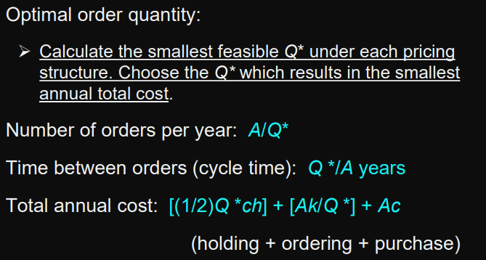

### Example

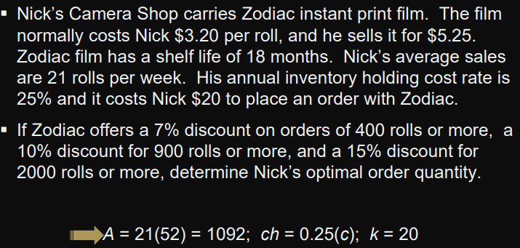 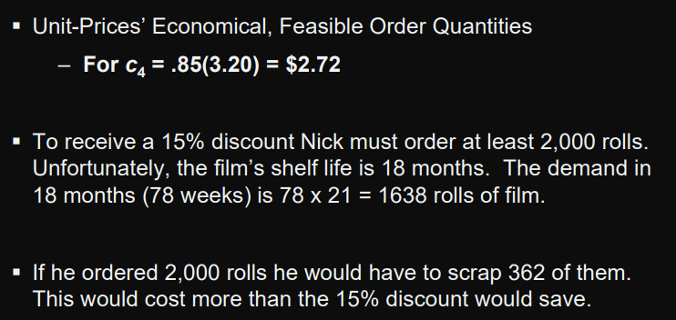 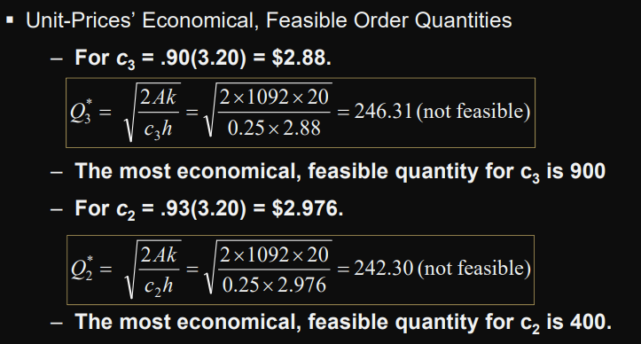 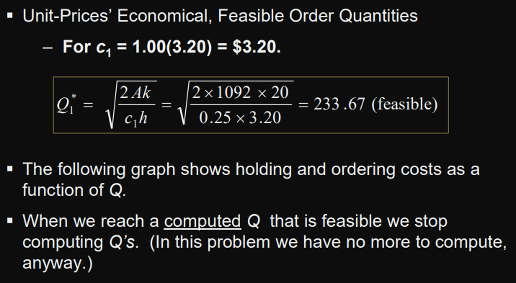 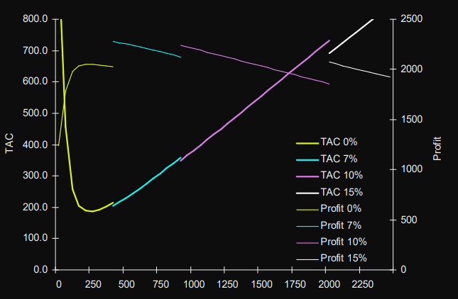 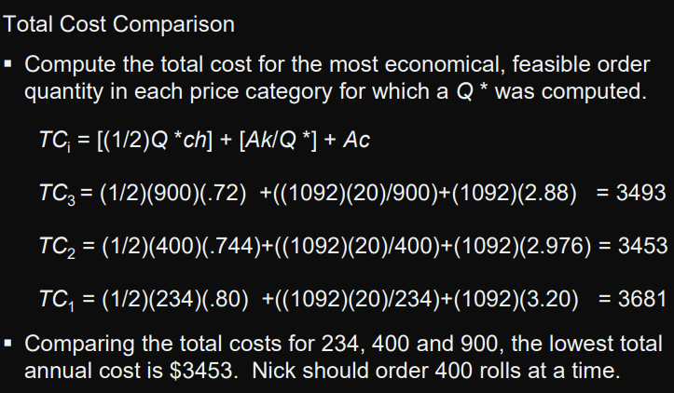

## Economic Production Lot Size

* economic production lot size model is a variation of the basic EOQ model
* replenishment order is not received in one lump sum as it is in the basic EOQ model
* Inventory is replenished gradually as the order is produced
* model’s variable costs are annual holding cost and annual set-up cost
* For the optimal lot size, annual holding and set-up costs are equal

### Assumptions

* Demand occurs at a constant rate of A items per year
* Production rate is B items per year (and B > A)
* Set-up cost: $k per run.
* Holding cost: $ch per item in inventory per year
* Manufacturing cost per unit is constant
* Set-up time (lead time) is constant.
* Planned shortages are not permitted

### Formulae

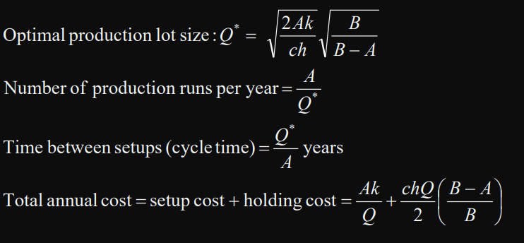

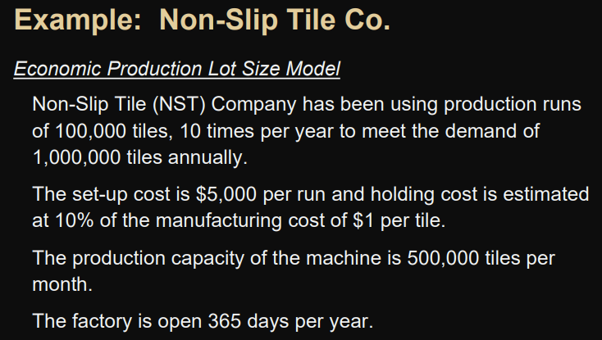 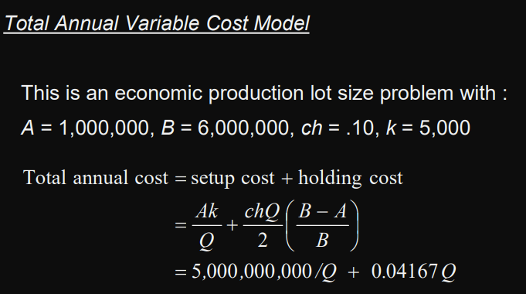 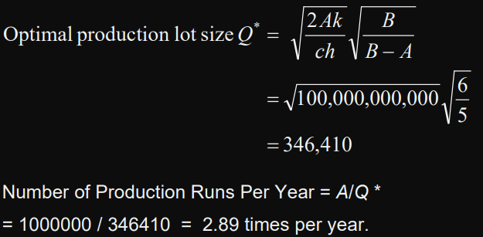 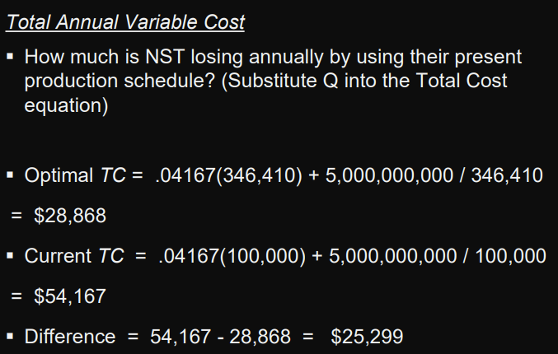 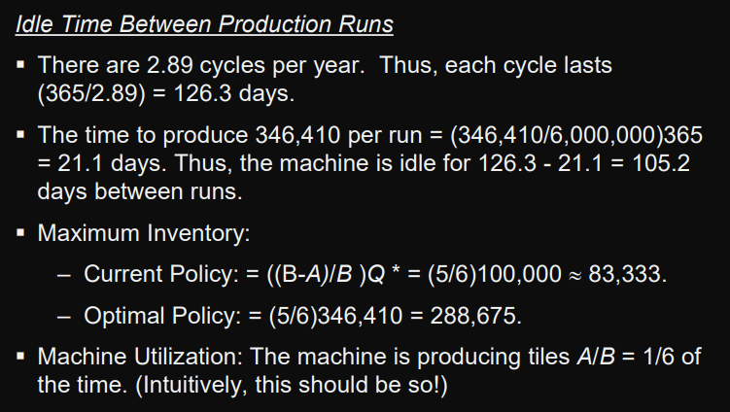

# W8

## Probabilistic Models

models tend to be more complex than deterministic models.

### Normal Distribution

* The Normal Distribution arises when we take the sums or means of a large number of observations from any distribution and thus provides the basis for sampling theory
* has a mean of 0 and a standard deviation of 1 and is called the Standard Normal.
* 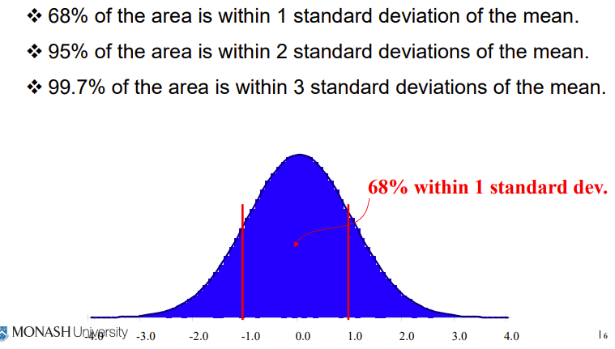
* 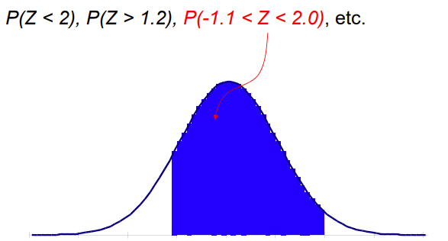

P(Z < a) when a is positive: P(Z < 1.33) = 0.9082

P(Z > a) when a is negative: P(Z > -0.07) = P(Z < 0.07) = 0.5279

P(Z > a) when a is positive: P(Z > 1.21) = 1 - P( Z < 1.21) ~ 1 - 0.8869 ~ 0.1131

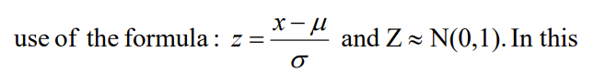

EXAMPLE:

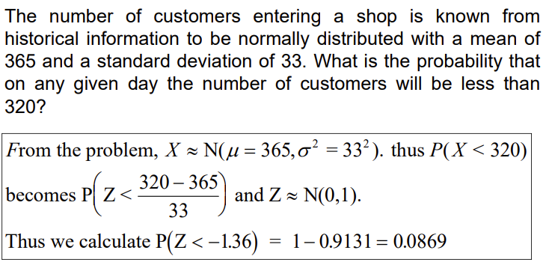

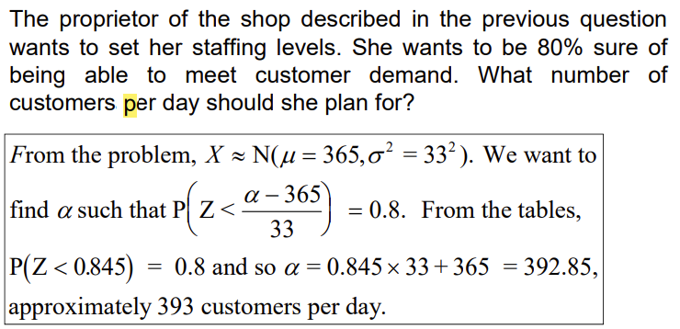 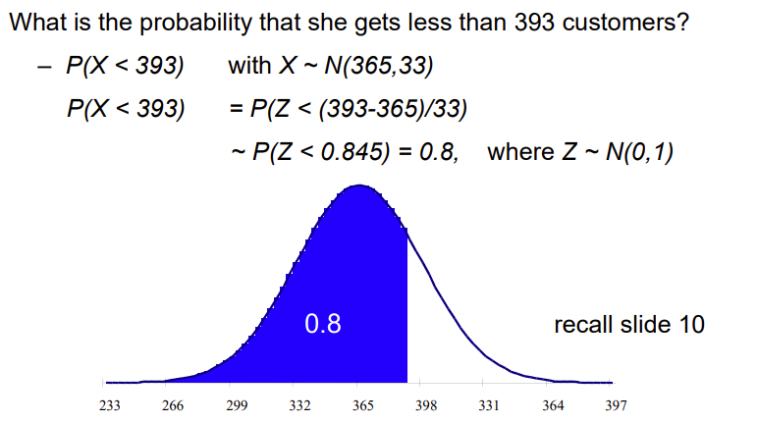

### Single-Period Order Quantity

* deals with a situation in which only one order is placed for the item and the demand is probabilistic
* If the period’s demand exceeds the order quantity, the demand is not back-ordered and revenue (profit) will be lost.
* If demand is less than the order quantity, the surplus stock is sold at the end of the period (usually for less than the original purchase price).

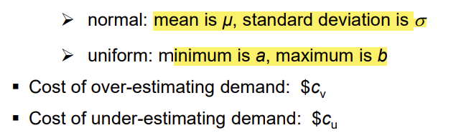 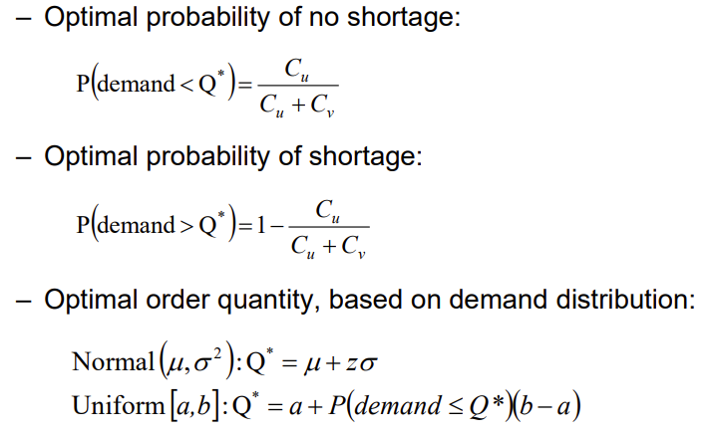 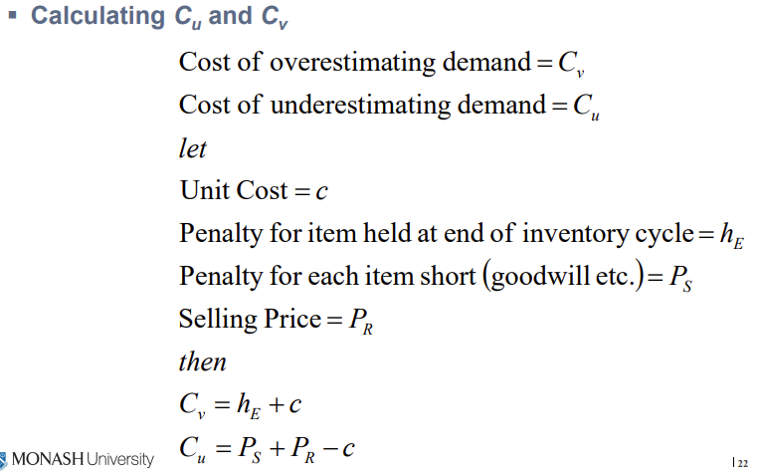 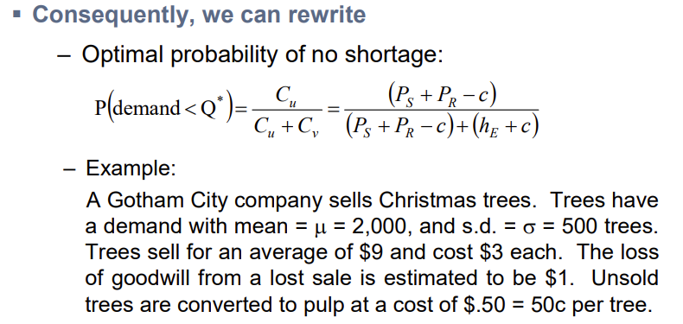 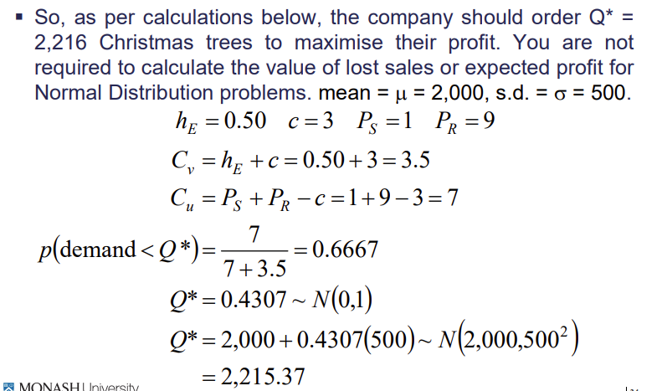 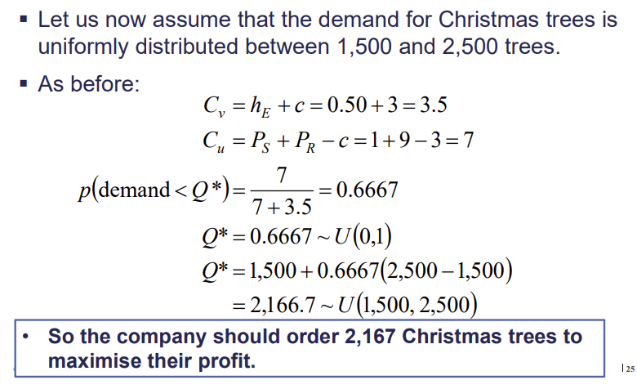 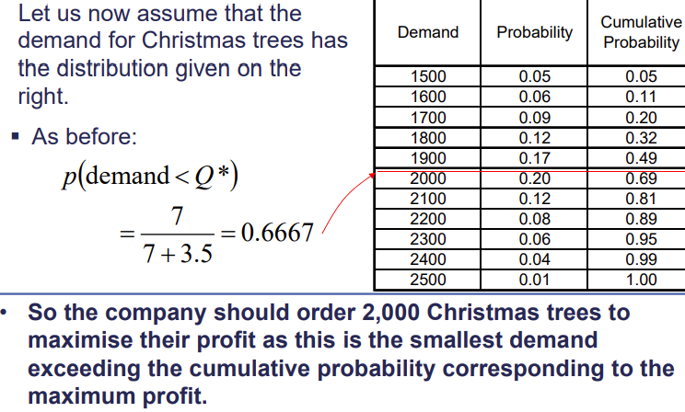

## Re-order Point Quantity

* A firm’s inventory position consists of the on-hand inventory plus on-order inventory (all amounts previously ordered but not yet received).
* An inventory item is re-ordered when the item’s inventory position reaches a predetermined value.
* The re-order point represents the quantity available to meet demand during lead time.
* Lead time is the time span starting when the replenishment order is placed and ending when the order arrives.
* Under deterministic conditions, when both demand and lead time are constant, the re-order point associated with EOQbased models is set equal to lead time demand.
* Under probabilistic conditions, when demand and/or lead time varies, the re-order point often includes safety stock.
* Safety stock is the amount by which the re-order point exceeds the expected (average) lead time demand

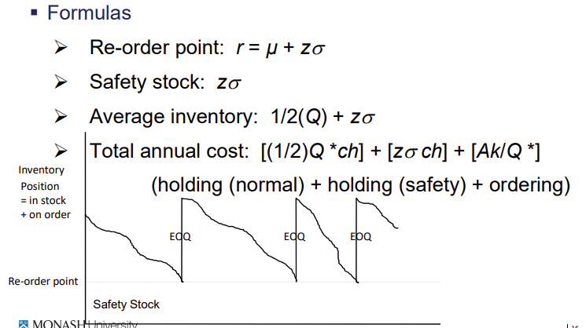

Example 1:

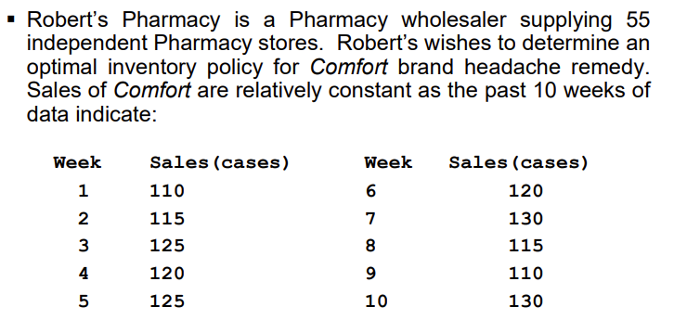 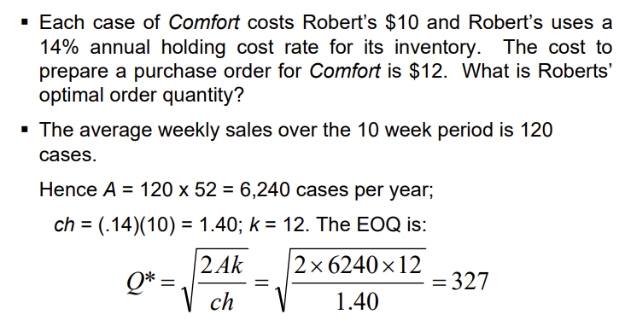

Example 2:

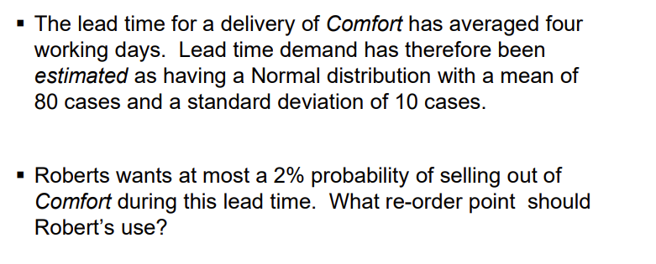 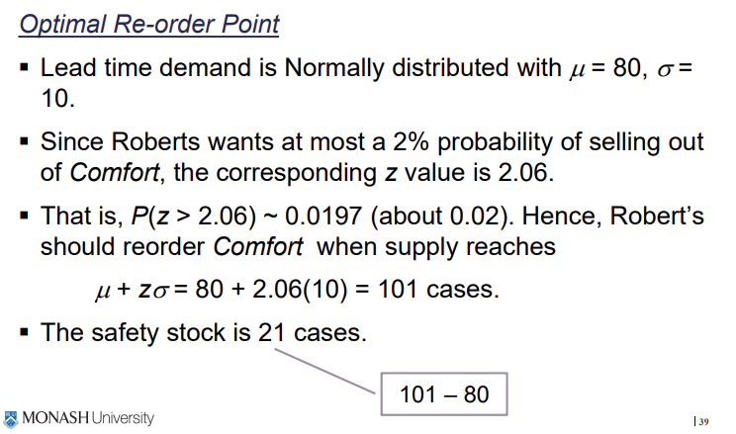 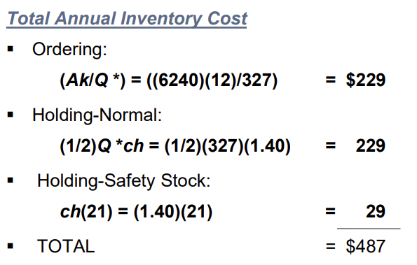

Highlight part:

Page 437

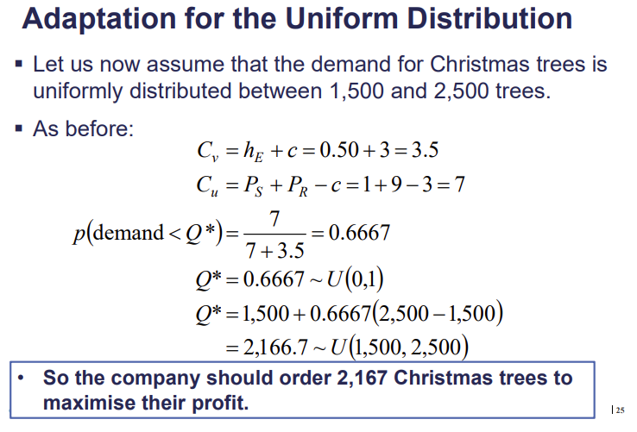

W9

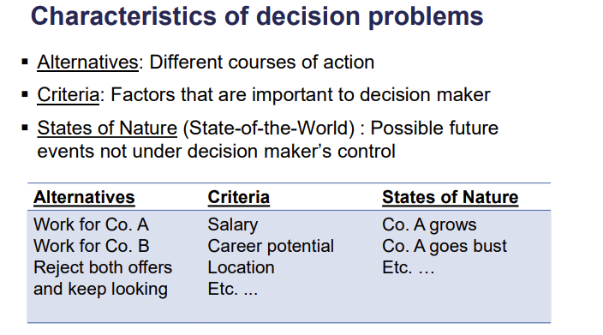 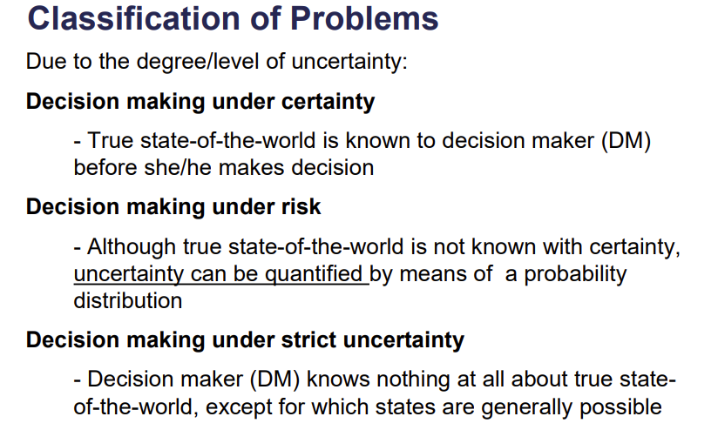 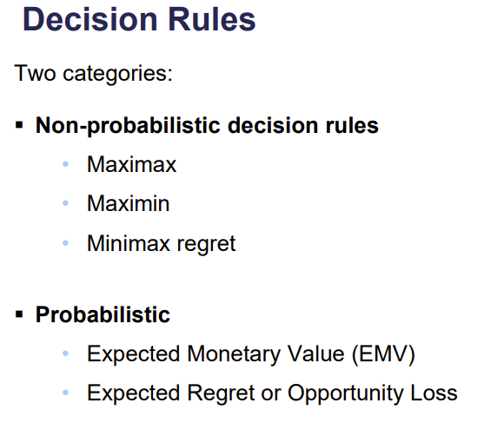

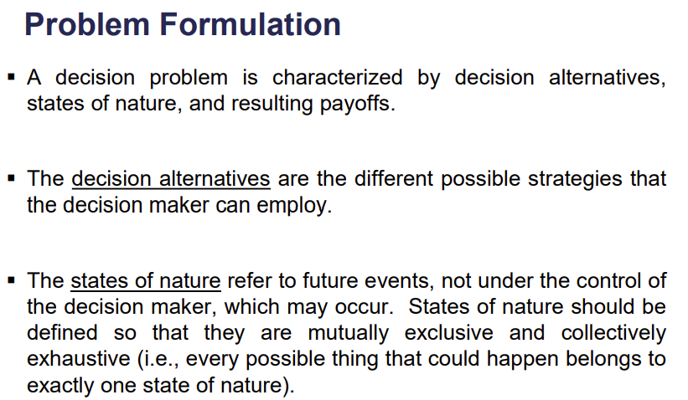

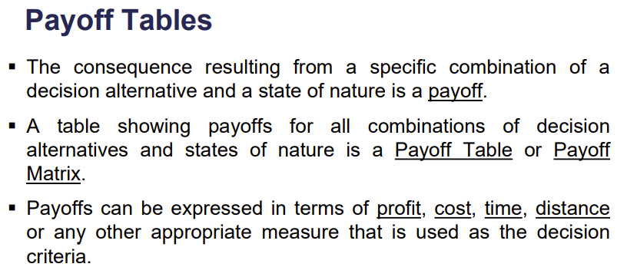 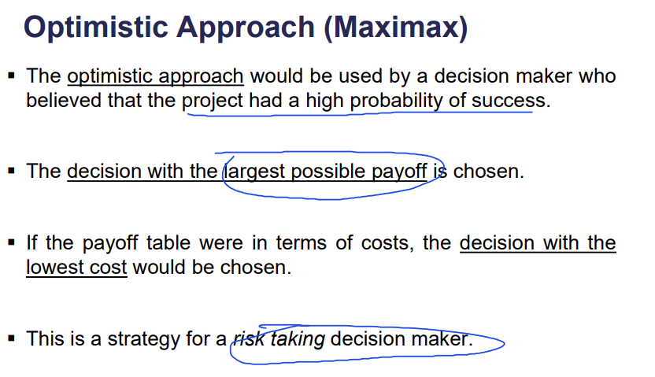 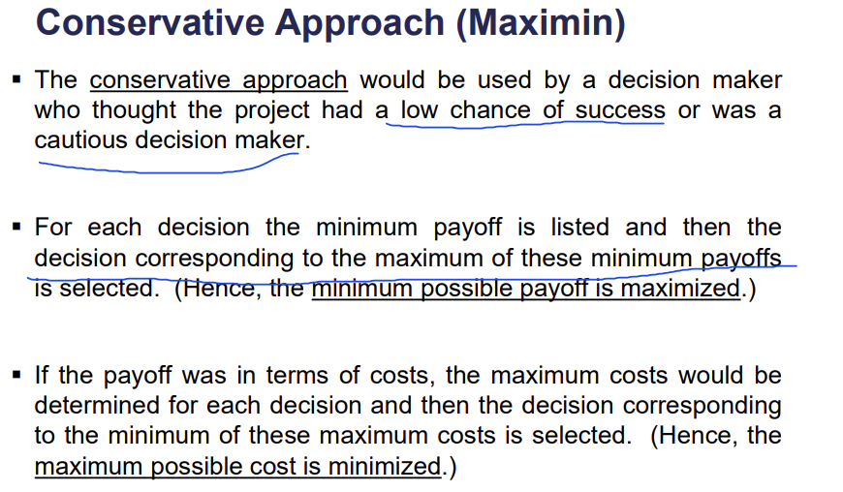 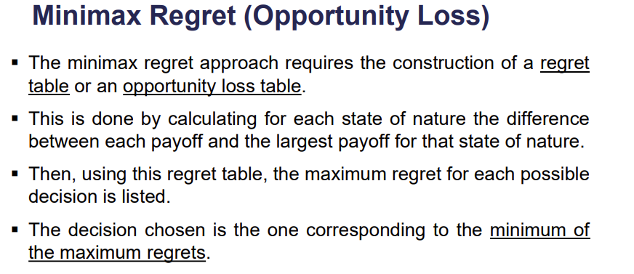

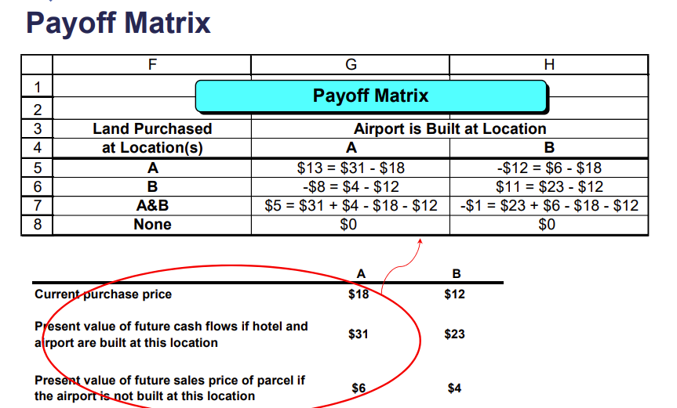

Maximax Purchase land at Location A.

Maximin Do not purchase land at either location

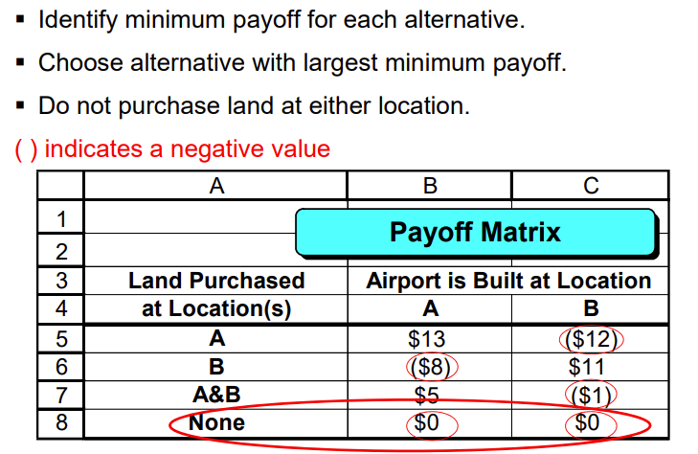

Magnolia Inns: Minimax Regret Criteria

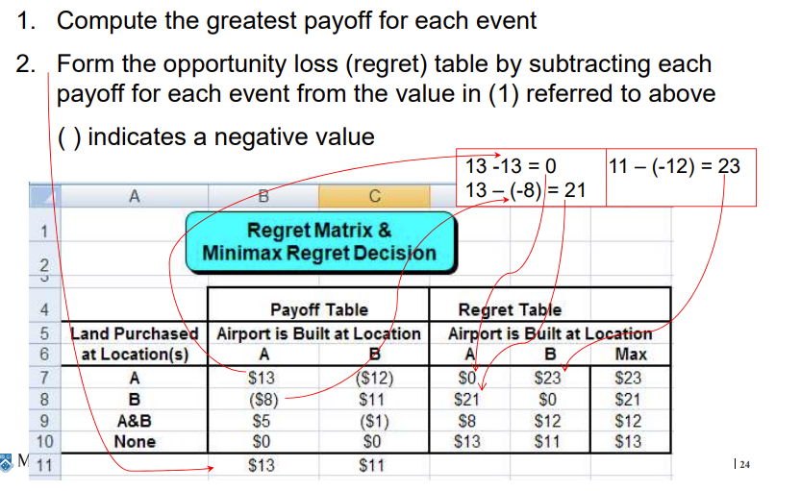 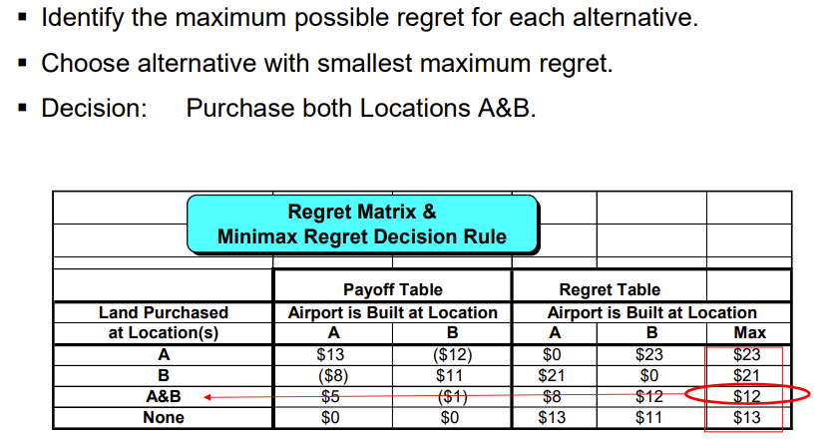

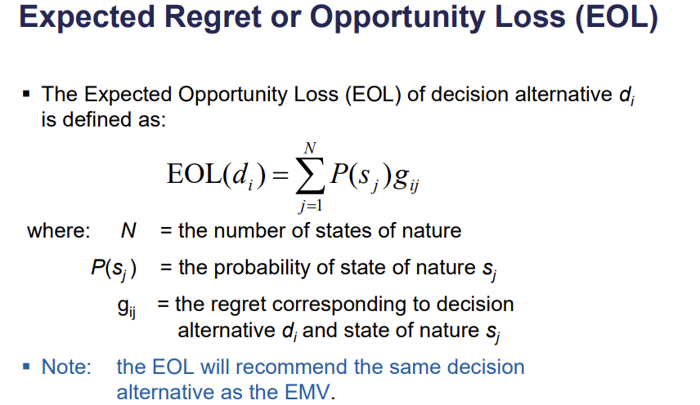 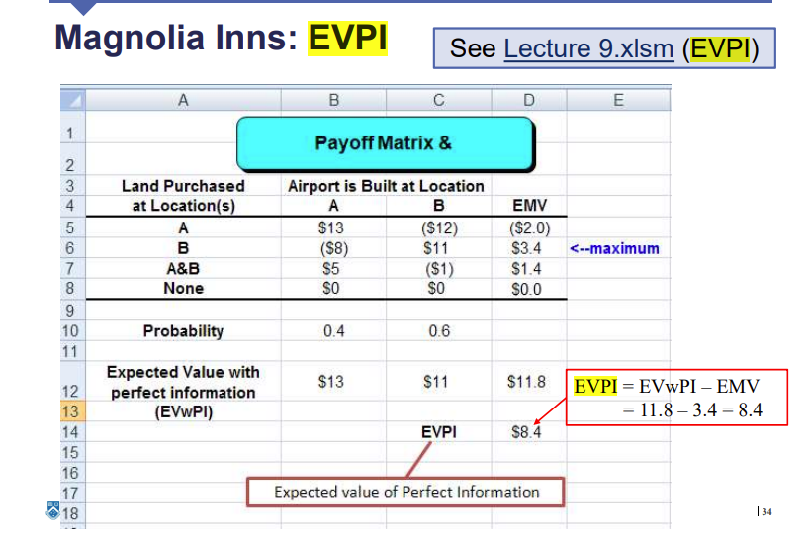

# W10

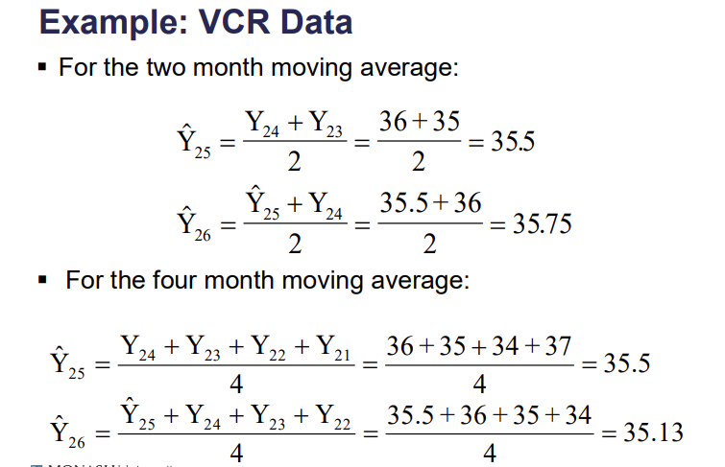

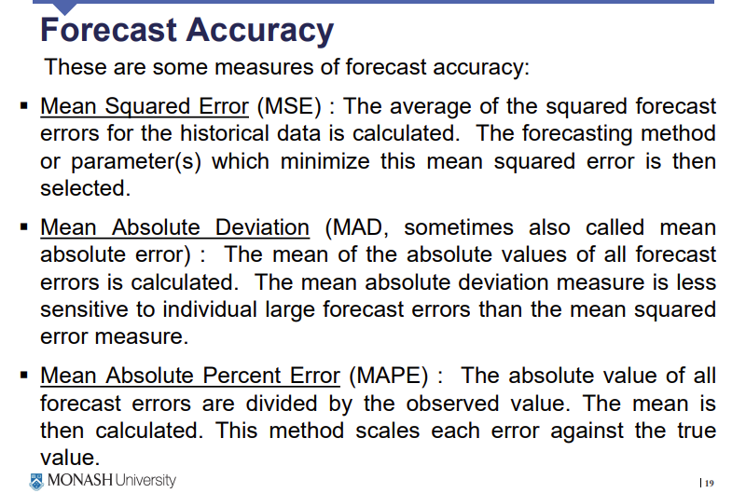

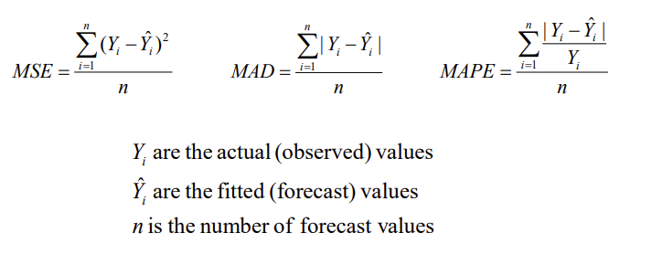

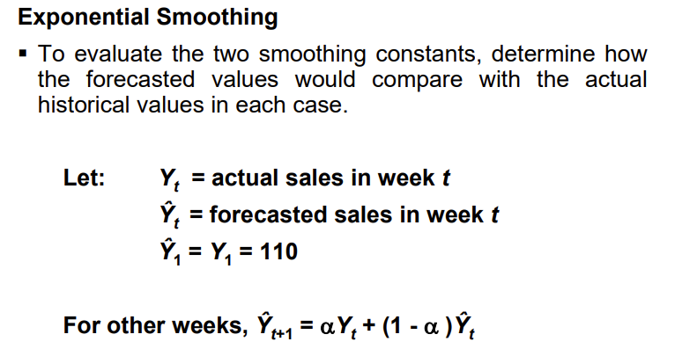

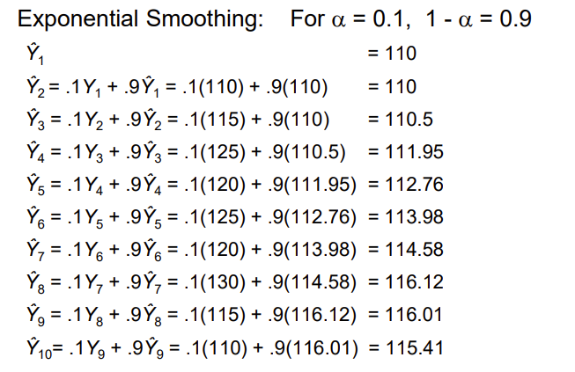

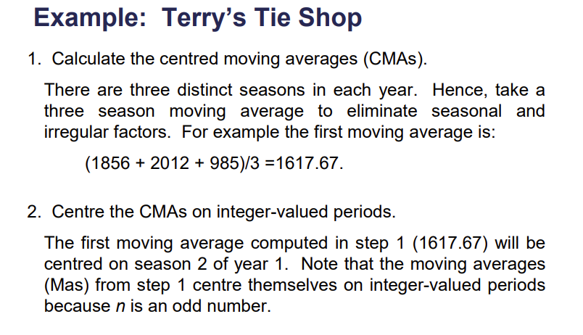 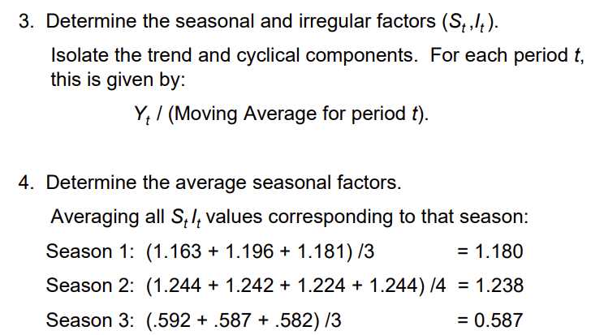 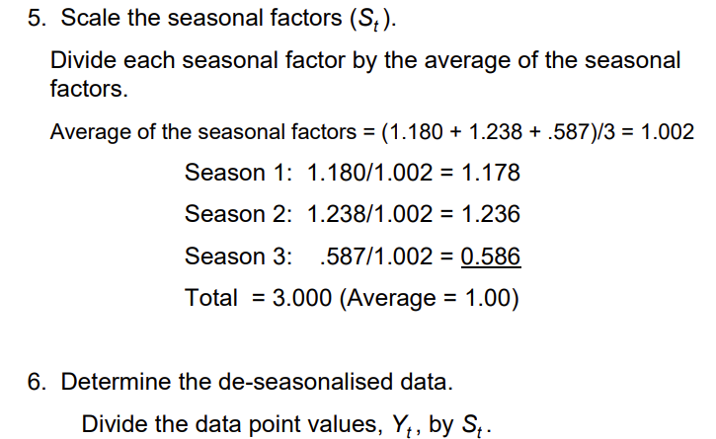 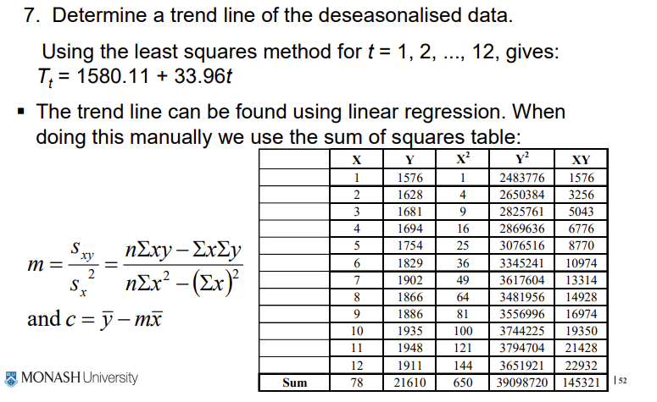 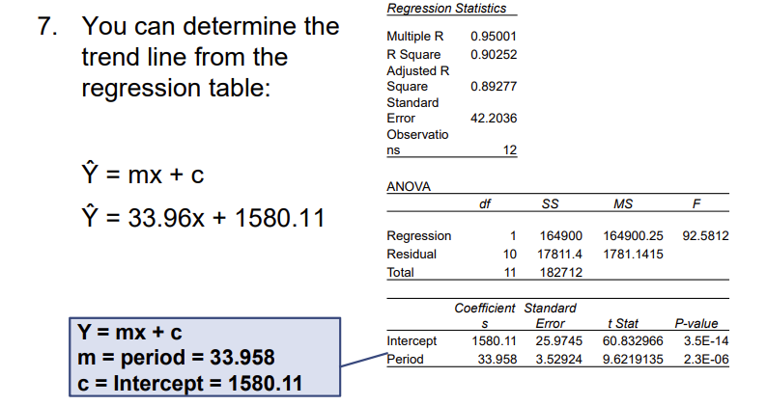 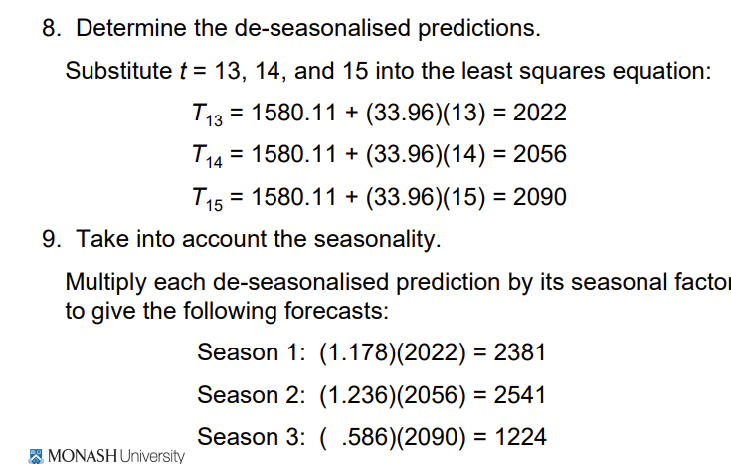

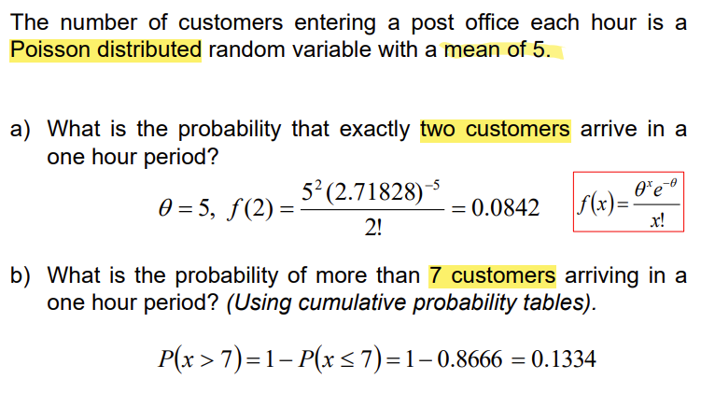 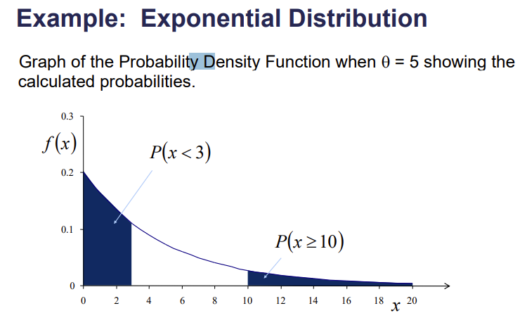

W11

